**Brigham and Women's Application User Manual**

CS3733-D21 Prof. Wong

Team E: Emerald Emus



Team Coach: Zachary Wong

Table of Contents

1. Login 4

1.1. Guest 4

1.2. Existing Account 5

1.3. Create Account 7

2. Pathfinder 8

2.1. Select Start and Destination 8

2.2. Select Floor 9

2.3. Clear Path 9

2.4. Click Functionality 10

2.5. Zooming 10

2.6. Directory 11

2.7. Categories 11

2.8. Detailed Directions 12

2.9. ETA and Distance 12

2.10. QR Code 13

2.11. Parking 13

2.12. Pathfinding for Special Circumstances 14

2.13. Change Pathfinding Algorithm 14

2.14. Help 15

3. Map Builder 16

3.1. Drag and Drop 16

3.2. Edit Node 17

3.3. Align Nodes 20

3.3.1. Align Horizontal 21

3.3.2. Align Vertically 23

3.4. Edit Edges 26

3.5. CSV 29

3.5.1. Upload 30

3.5.2. Retrieve 31

4. User Management 33

4.1. Add User 33

4.2. Delete User 34

4.3. Edit User 36

5. Service Requests 37

5.1. Floral Delivery 38

5.2. Food Delivery 39

5.2.1. Au Bon Pain Page 39

5.3. Language Interpreter 40

5.4. Religious Request 41

5.5. Laundry Request 41

5.6. Sanitation Request 42

5.7. Medicine Delivery 42

5.8. Security Services 43

5.9. Facilities Maintenance 43

5.10. Internal Patient Transport 44

5.11. External Patient Transport 44

5.12. Service Request Status 45

6. To-Do Scheduler 45

6.1. Create Custom Task 46

6.2. Edit task or view task details 54

6.3. Mark task as completed/ongoing 56

6.4. Delete a To-Do 57

6.5. Show Today’s Scheduled Path 58

6.6. Editing To-Dos that are linked to service requests or appointments: 60

6.7. Edit To-Dos that are Linked with Appointments 60

7. Directions to Brigham and Women’s 62

7.1. Address Entry 63

7.2. Transit Mode Change 64

7.3. Directions to Brigham and Women’s 64

7.4. Directions from Brigham and Women’s 65

7.5. Returning to the Home Page 65

8. Appointment Scheduling 66

9. COVID Survey 72

9.1. Filling Out a COVID Survey 72

9.2. Approving a User for Entry 73

10. Logger 74

11. Crash Report 74

# Login

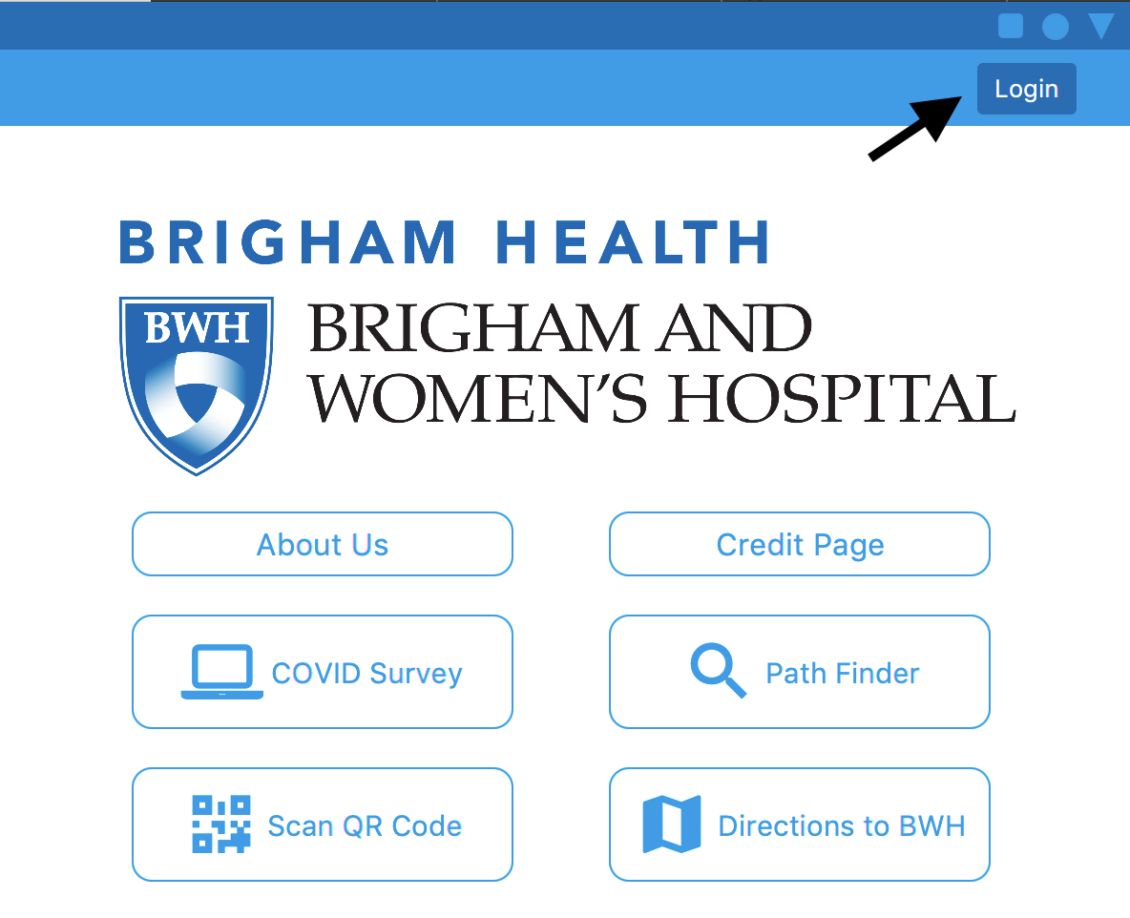

Select the **Login** button in the upper righthand corner of the application window.

## Guest

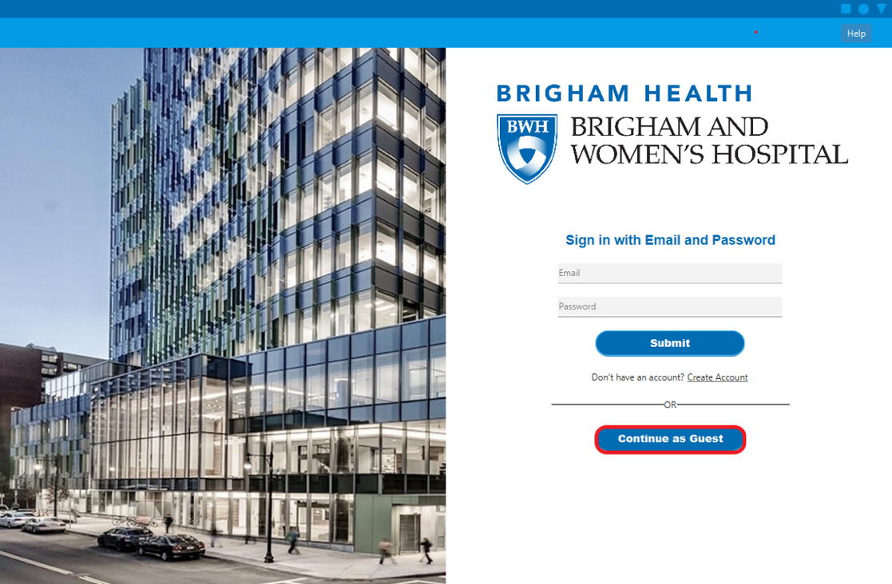

Select the **Continue as Guest** button. If the user does not log in originally they will automatically be entered as a guest.

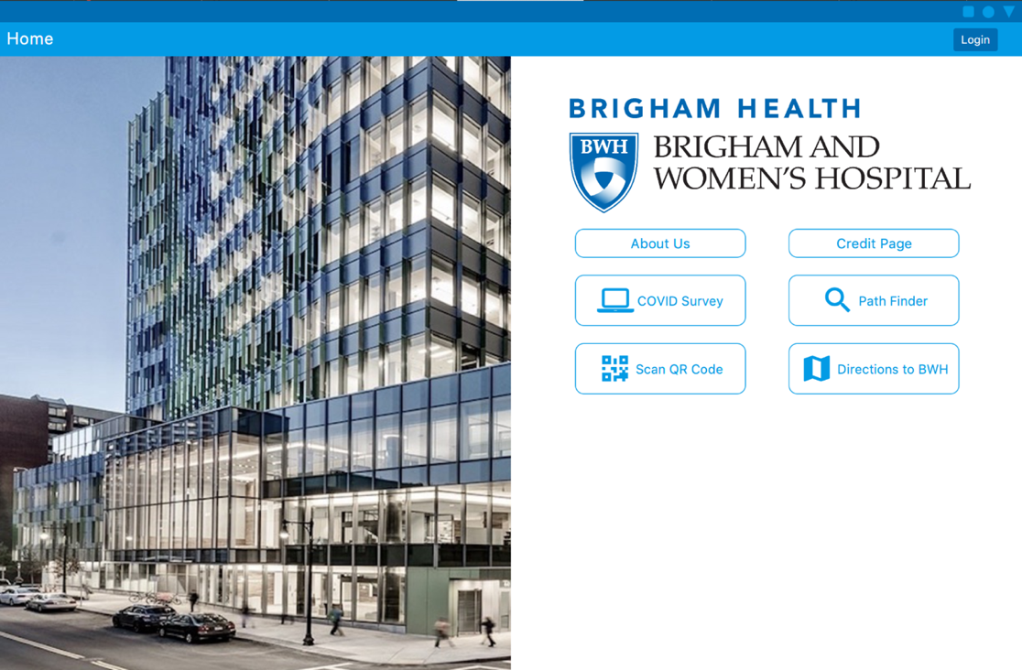

This is the default page when the guest user is logged in.

## Existing Account

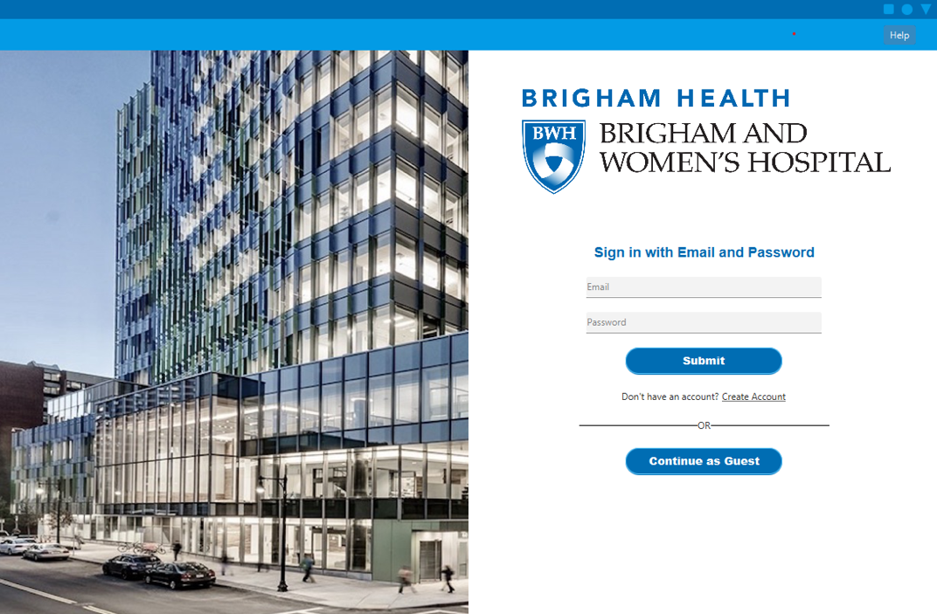

Enter existing credentials into the **Email** and **Password** text fields to log in to an existing account.

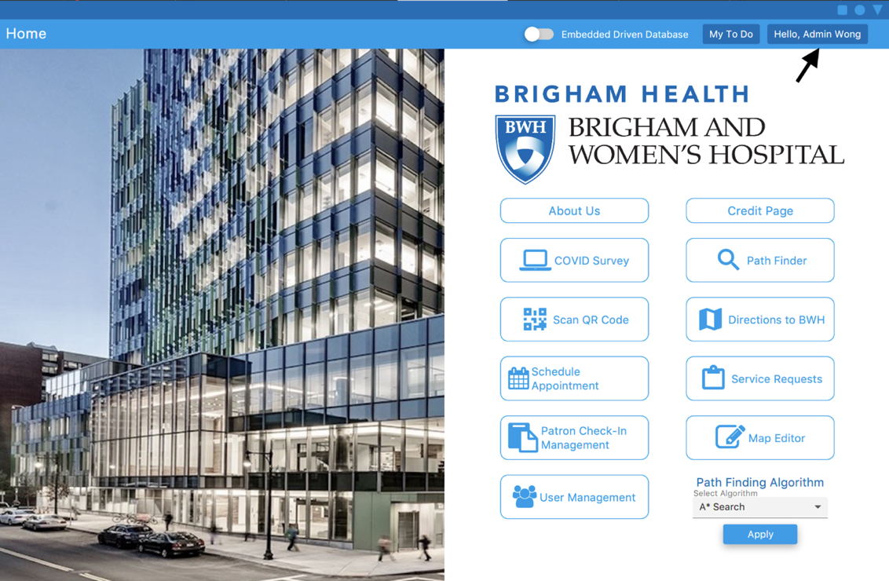

This is the admin default view, they have access to more functionality. To log out they reclick the button for logging in.

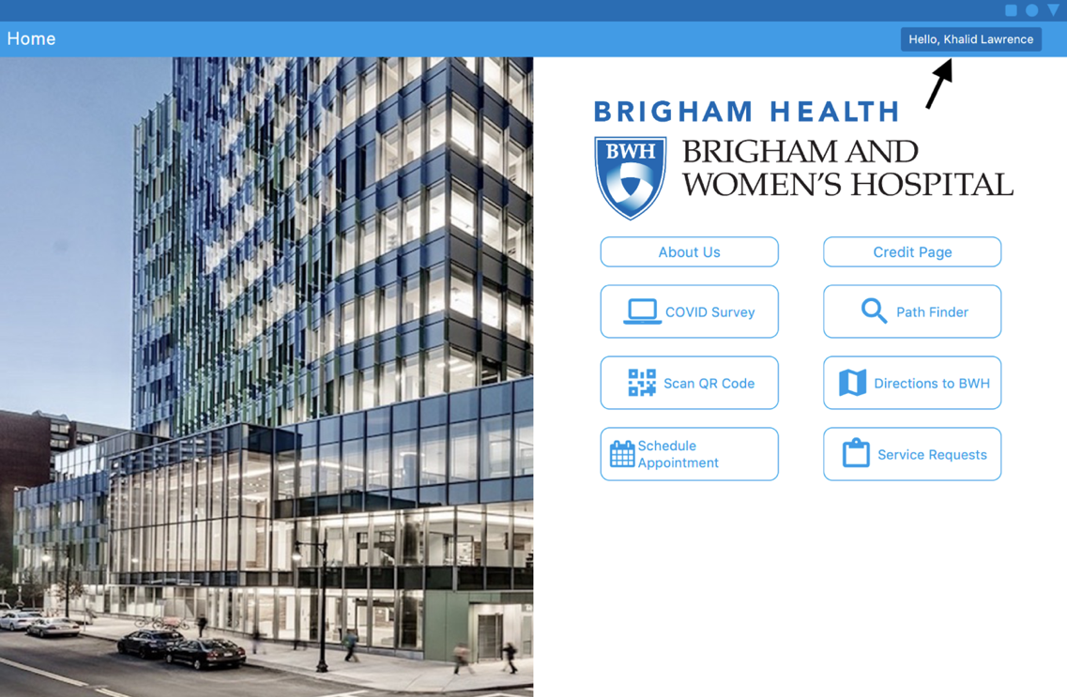

This is the visitor default view, they have access to a few more features than the guest user.

## Create Account

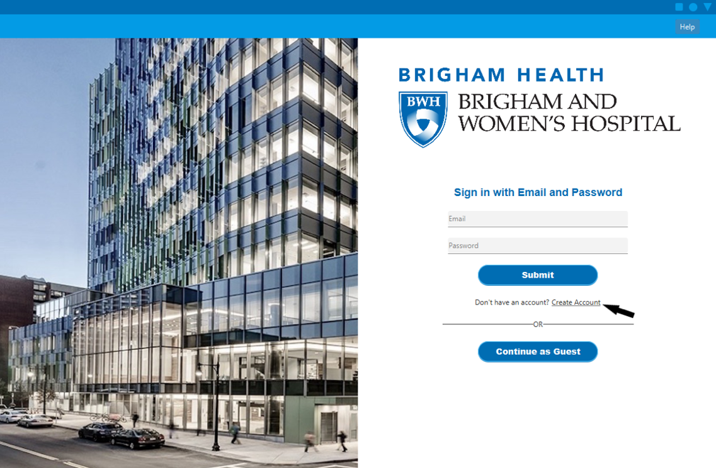

Click on **Create Account**.

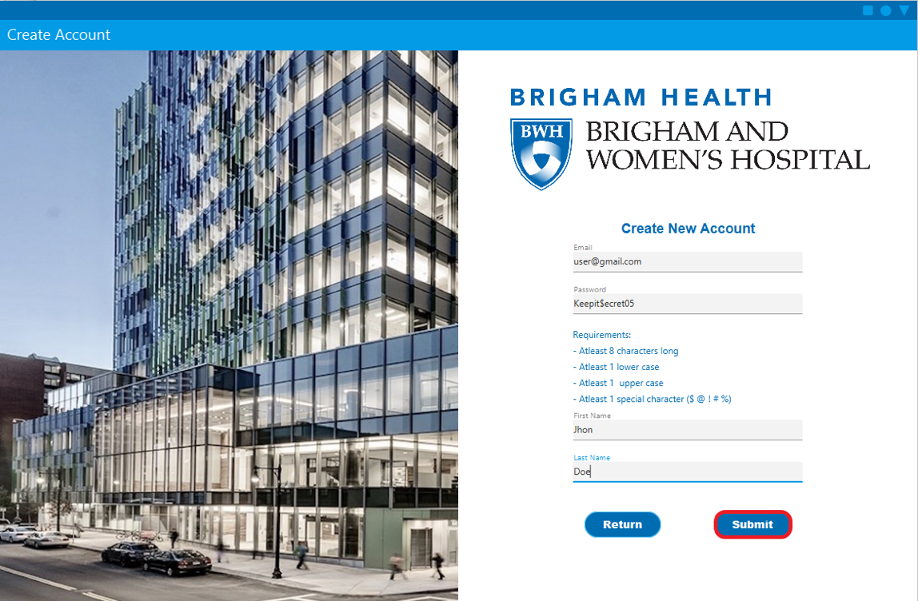

Fill out the **Email**, **Password**, **First Name** and **Last Name** with appropriate inputs. Then select the **Submit** button.

# Pathfinder

## Select Start and Destination

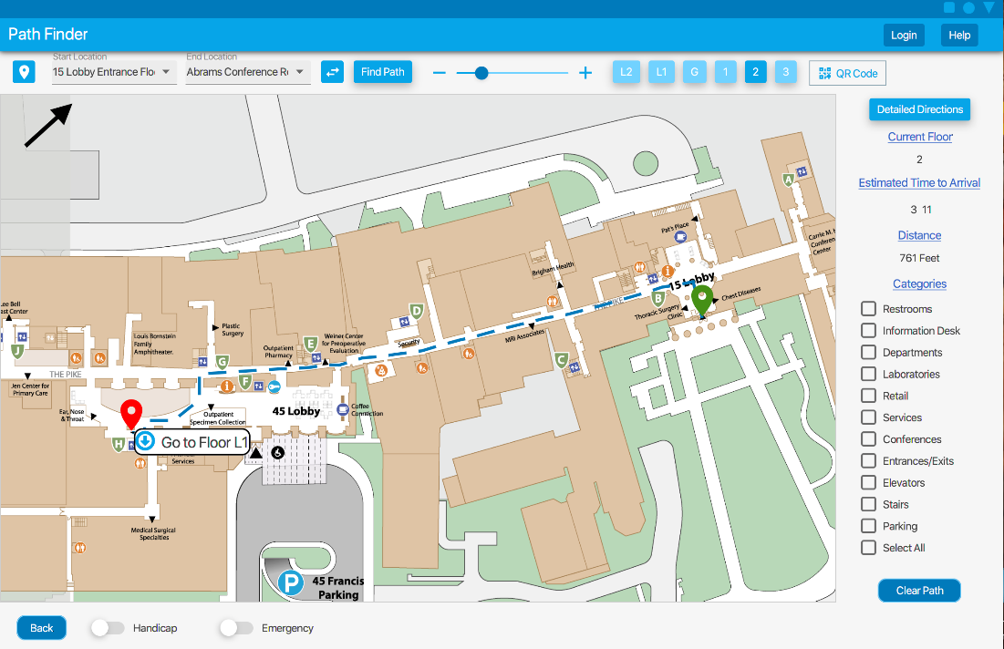

After logging in and selecting the pathfinder icon on the main screen, select from the drop down a start location and a destination. If you have not logged in, you will be reminded that in building pathfinding as a guest is for remote (at home) use only. The text fields can be filled with autocomplete, so you can type in a location or select from the menu. Then click **Find Path**, a path will be shown.

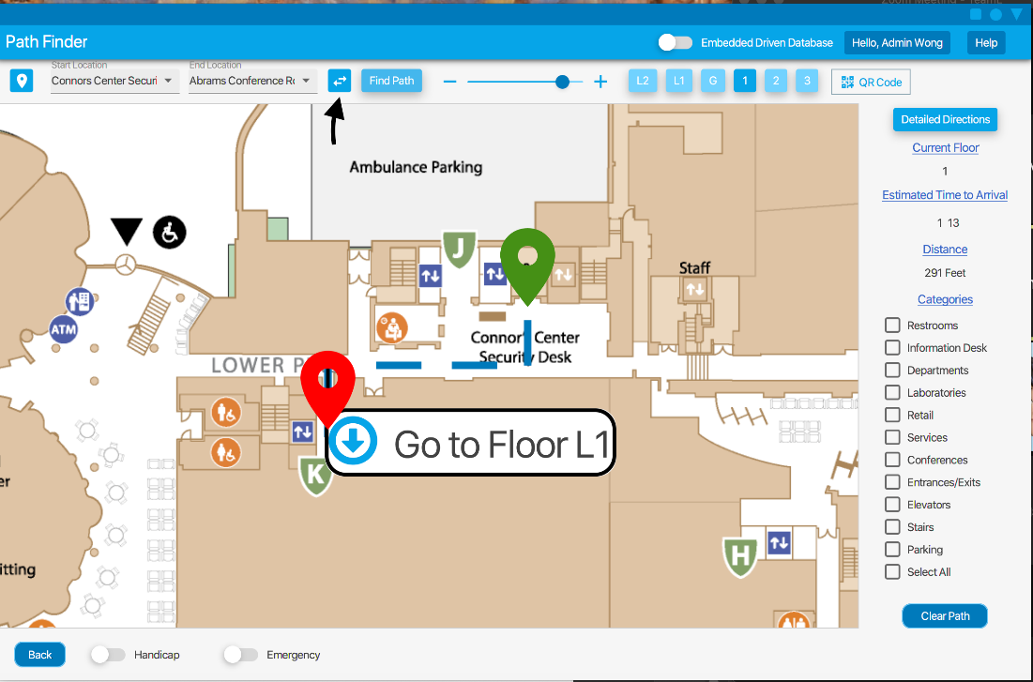

To reverse the locations, select the **swap** button. Remember green is the start, and red is the destination.

## Select Floor

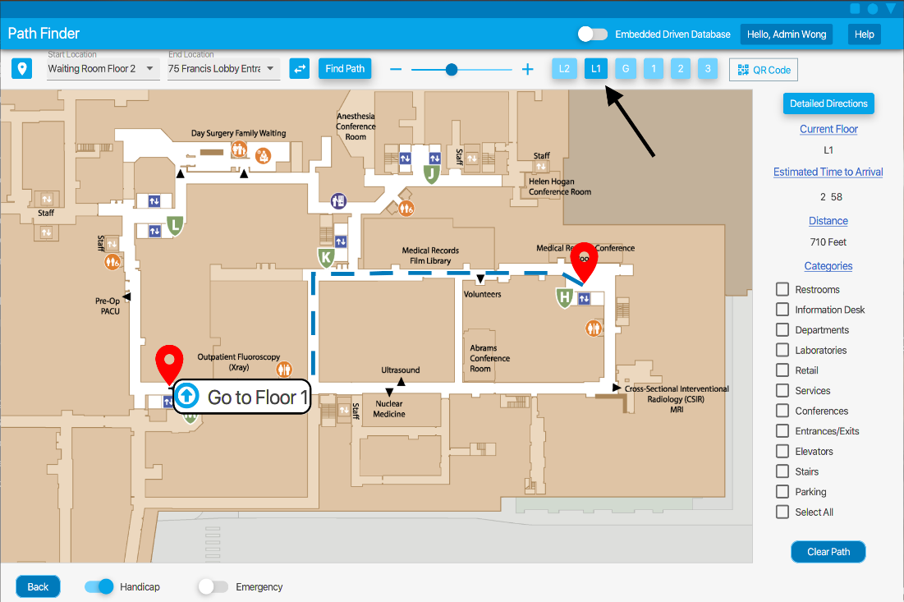

Use the buttons at the top of the application to see different floors on the map. If a path has been drawn that will take you to another floor, click the label with the “Go to Floor” text.

## Clear Path

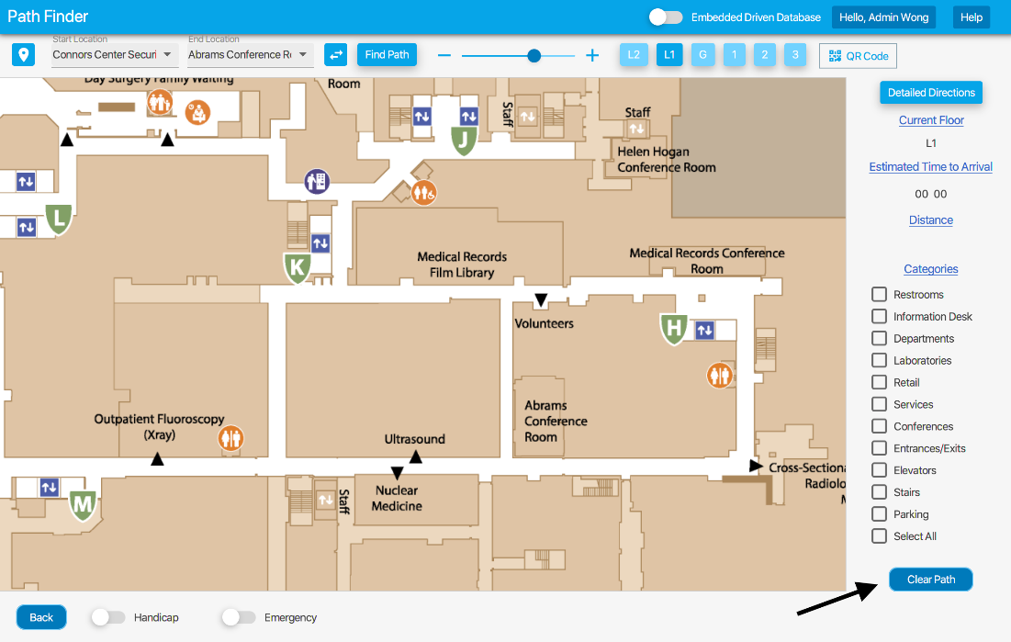

To clear the path from the screen, select **Clear Path.**

## Click Functionality

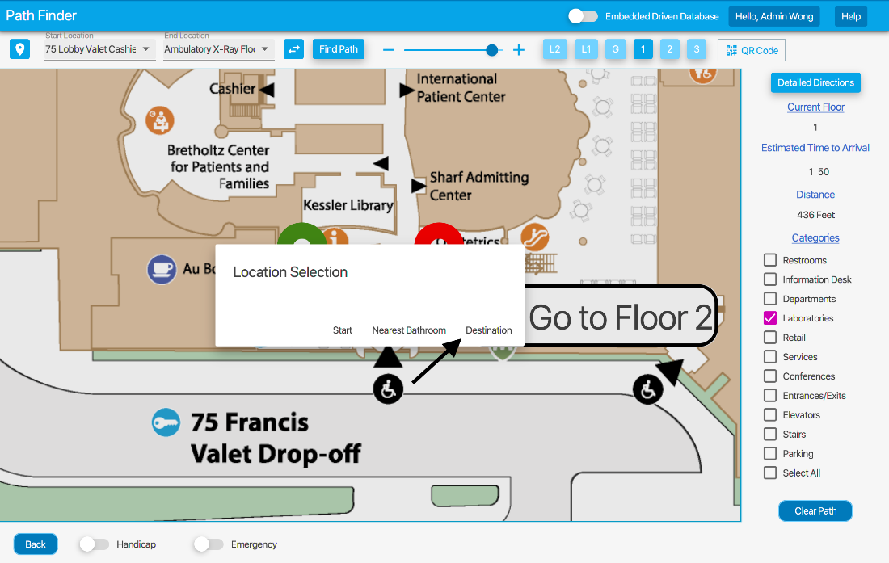

An alternative to selecting locations from the dropdown is by pressing anywhere on the map. Click where you want to go by first selecting a category and then selecting one of the colored icons, then **Destination**. If in need of a bathroom, select nearest bathroom, then **Find Path**.

## Zooming

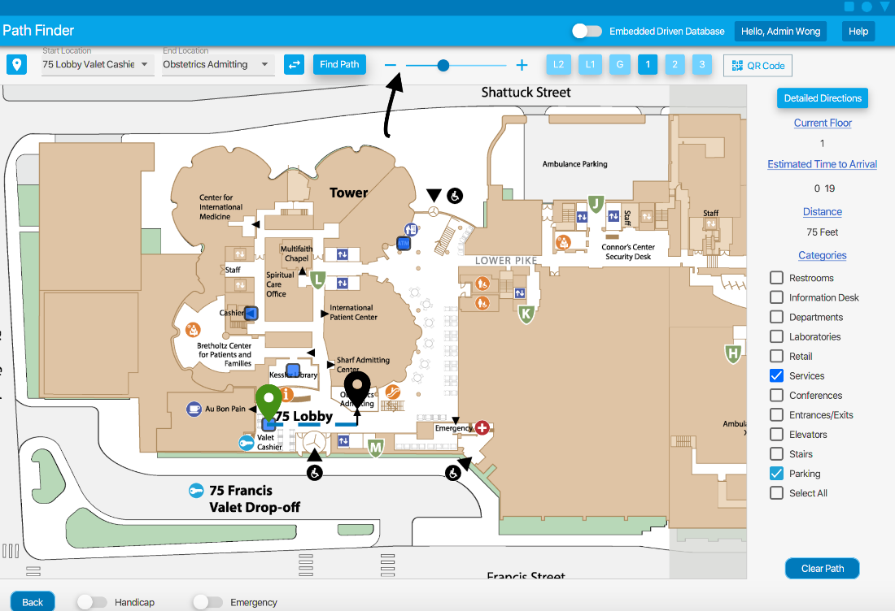

To zoom in and out simply drag the **slider** or click on the **+**/**-** button.

## Directory

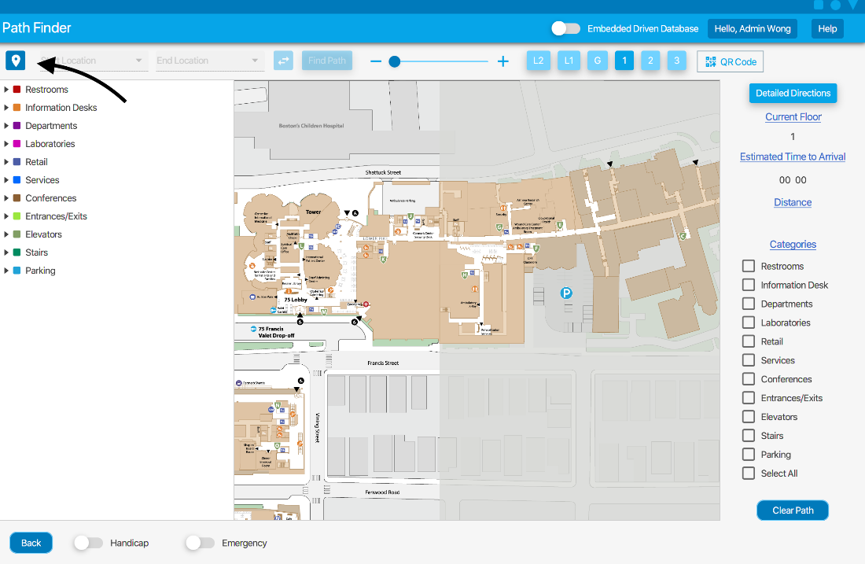

To access the directory for all possible locations, sorted by category, select the top left icon to access the dropdown.

## Categories

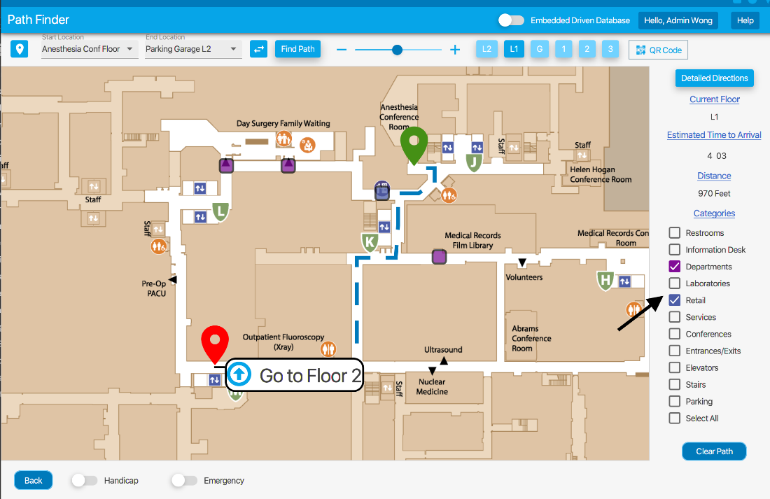

To see different types of locations on the map select any of the categories right to display their location on the map.

## Detailed Directions

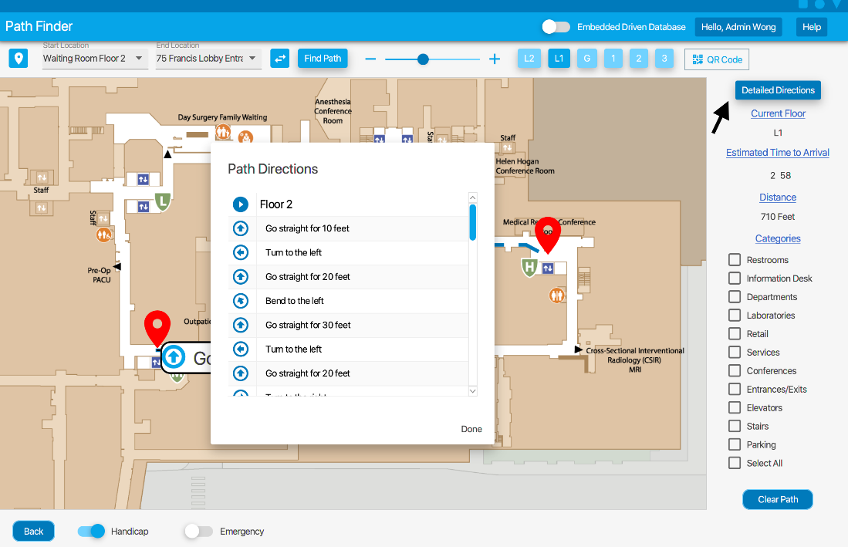

To see detailed directions of your path, select **Detailed Directions** on the right-hand side of the screen. Directions include floor labels, distances, categorized turns, floor change instructions, and icons depicting the direction for ease of use.

## ETA and Distance

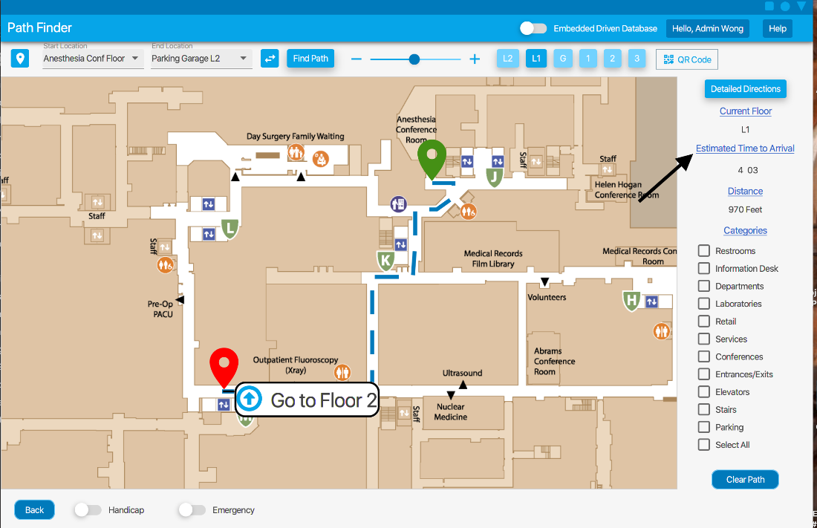

The right-hand side of the page will show the current floor, the length of the path, and the estimated time to arrival.

## QR Code

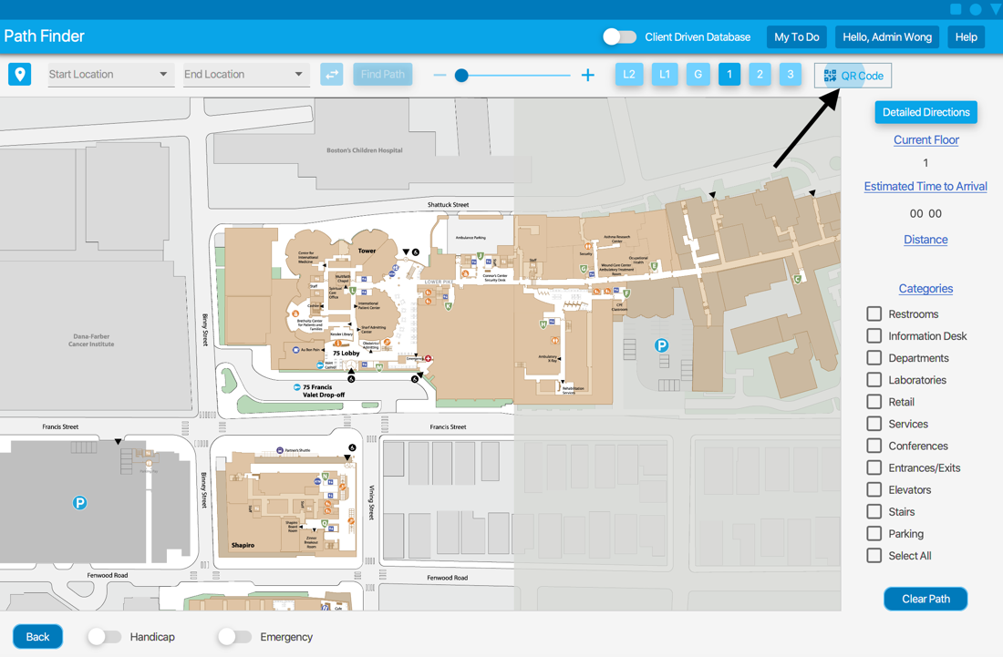

The start location can also be selected via QR codes posted around the hospital. To do this, simply hit the QR Code button, which will bring up your webcam display. Hold your webcam up to the nearest QR code and the application will automatically fill in the ‘Start Location’.

## Parking

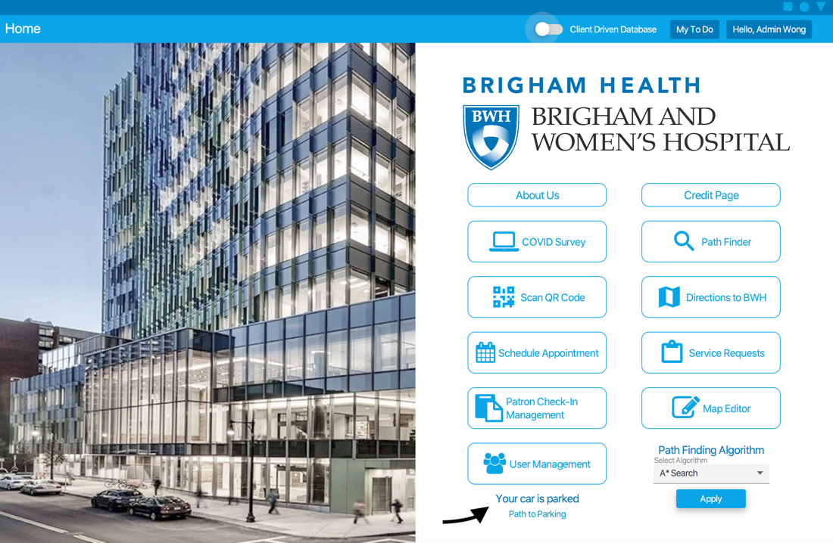

There are also QR codes at each parking space, which can be scanned to have the application save that parking space. Then, once logged in, the When you park you can scan these and the application will save this as your parking spot.

## Pathfinding for Special Circumstances

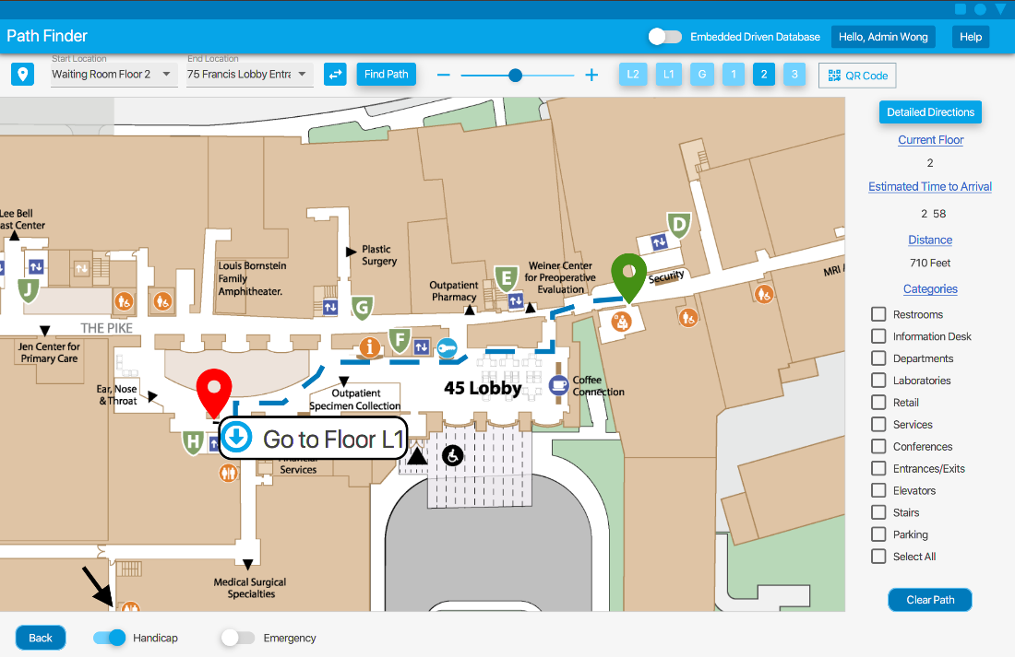

If handicapped or in an emergency, select the toggles at the bottom before clicking Find Path to plan the fastest and/or most accessible route. Handicapped prevents the path from taking stairs and only uses elevators, while Emergency will take a path through the ER if that is faster and having Emergency unselected will prevent the path from going through the ER.

## Change Pathfinding Algorithm

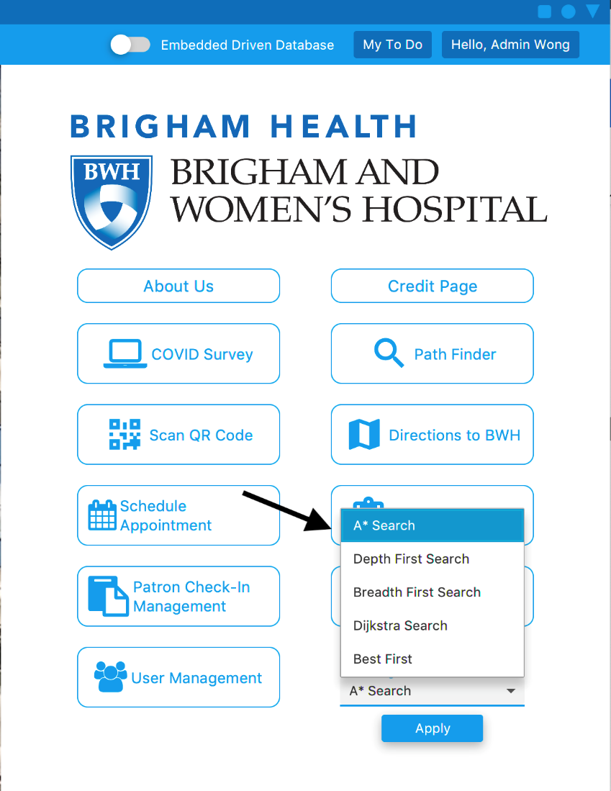

After logging in, an admin as abled to change the pathfinding algorithm by selecting the desired algorithm from the dropdown.

Once the map is visible again, select a start and a destination to display that algorithm's path.

## Help

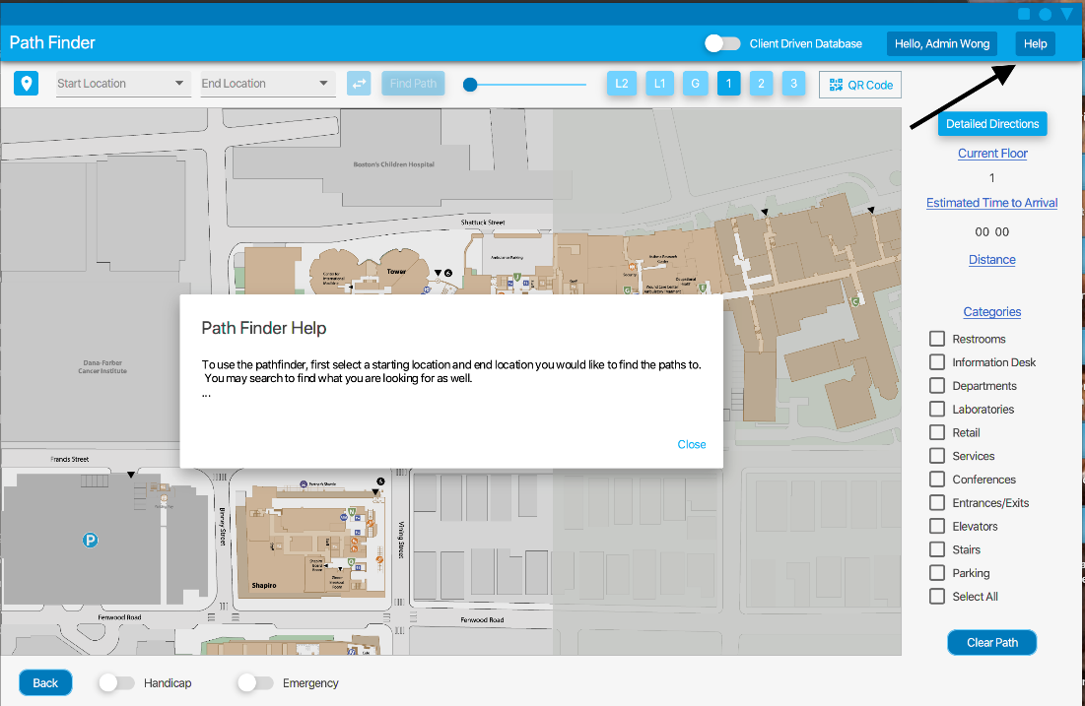

If having trouble accessing any features, select the **Help** button located at the top right corner of the screen for more information.

# Map Builder

## Drag and Drop

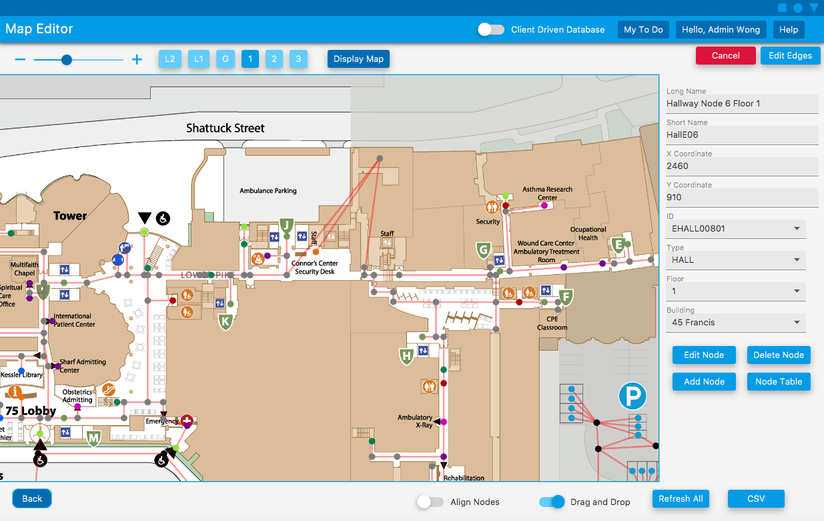

To enter drag and drop mode select the **Drag and Drop** button, then select a node and move it to the desired location.

## Edit Node

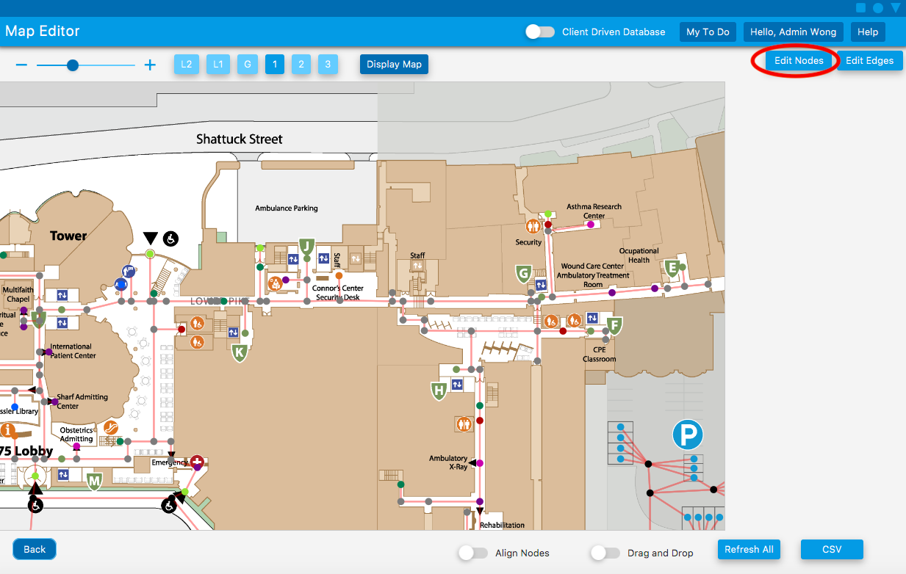

To edit a node on the map select the **Edit Nodes** button.

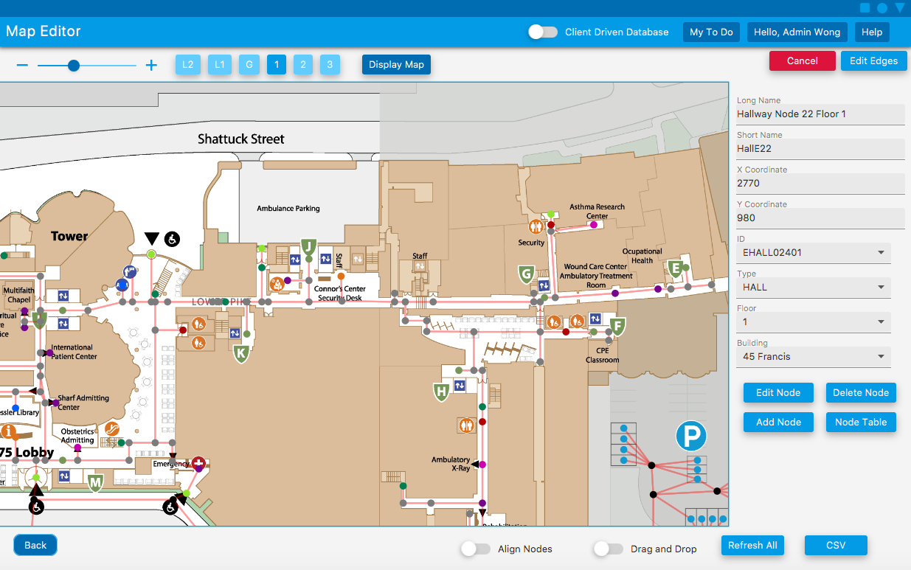

Select the desired node and modify the desired field.

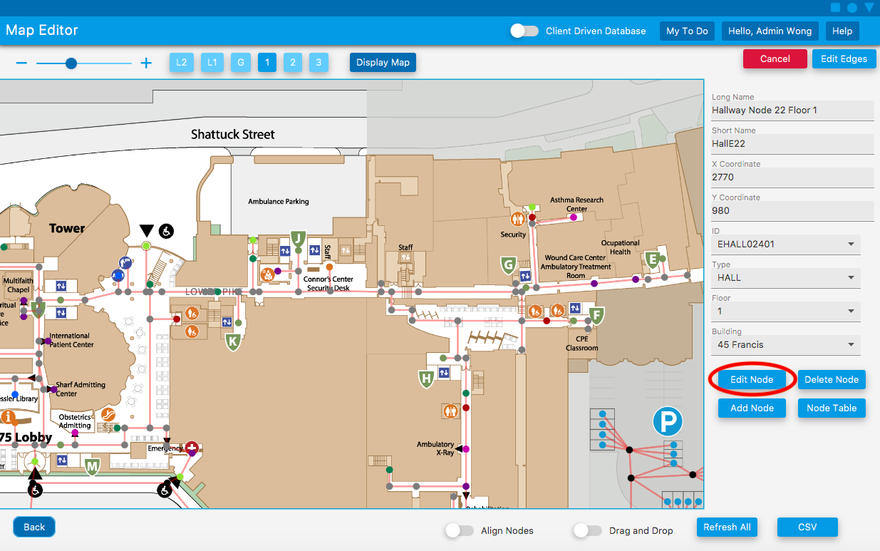

When you are finished modifying the desired field or fields click on the **Edit Node** button.

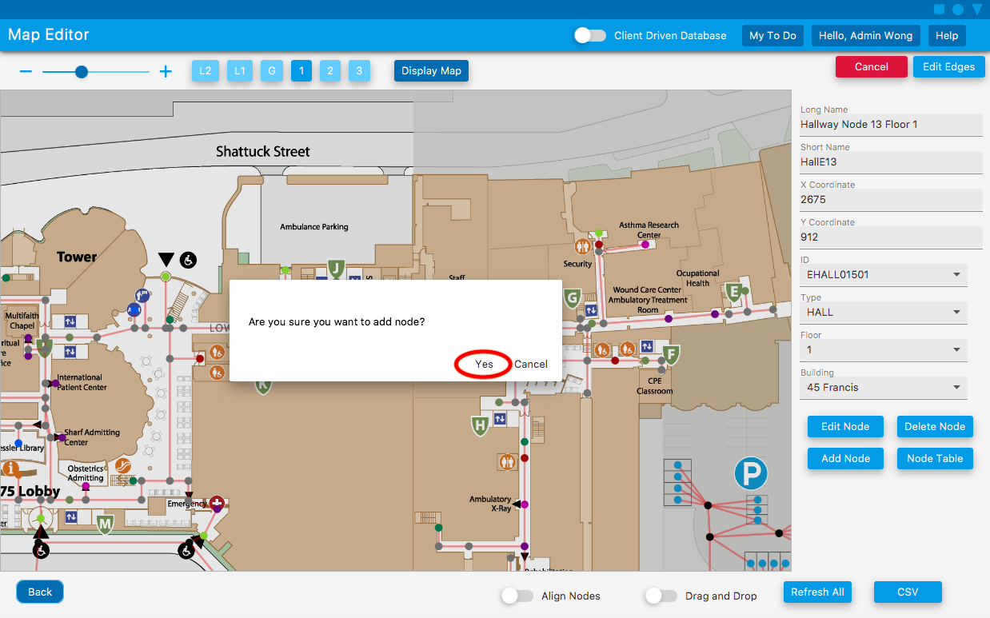

If you truly wish to edit this node on the pop up select **Yes** if not select **Cancel**.

## Align Nodes

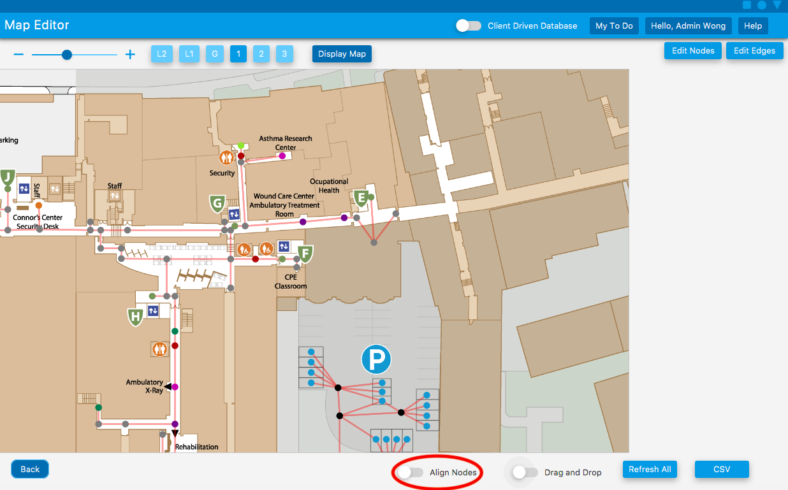

Select the **Align Nodes** button.

### Align Horizontal

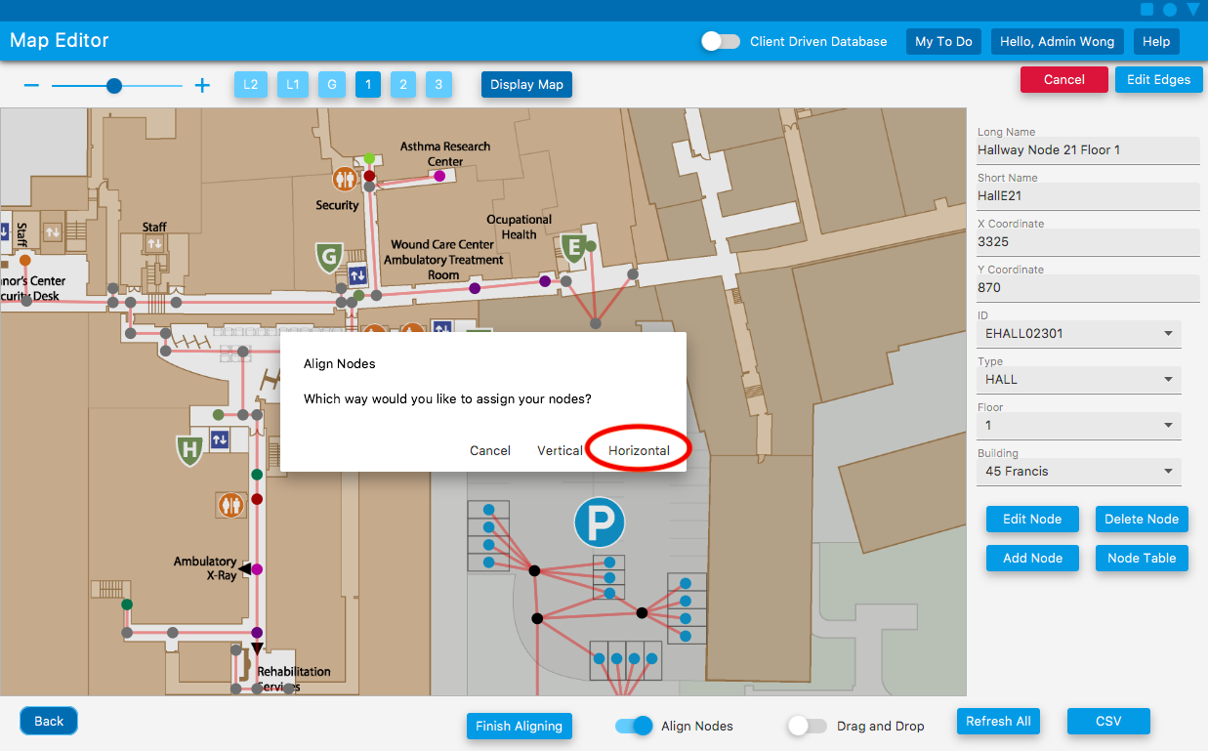

Select the **Horizontal** button on the popup.

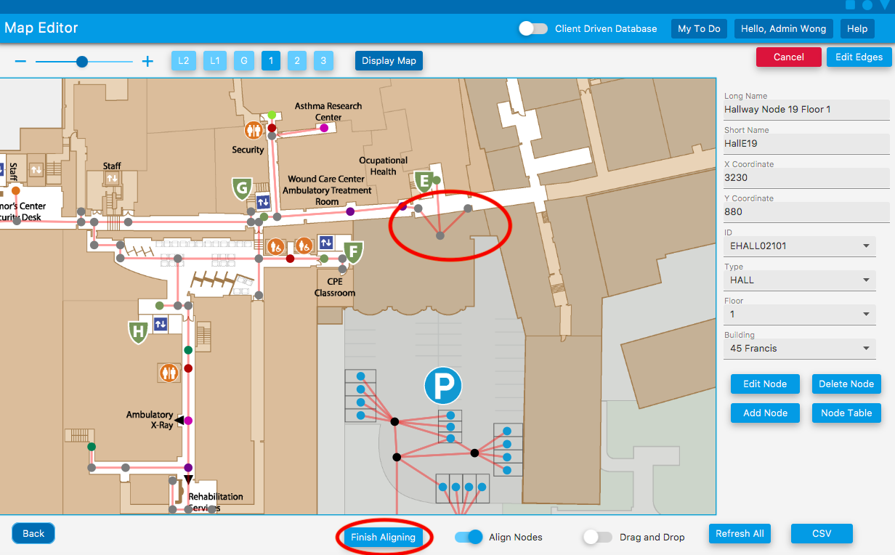

Double click on each node you would like to align, and select **Finish Aligning** button

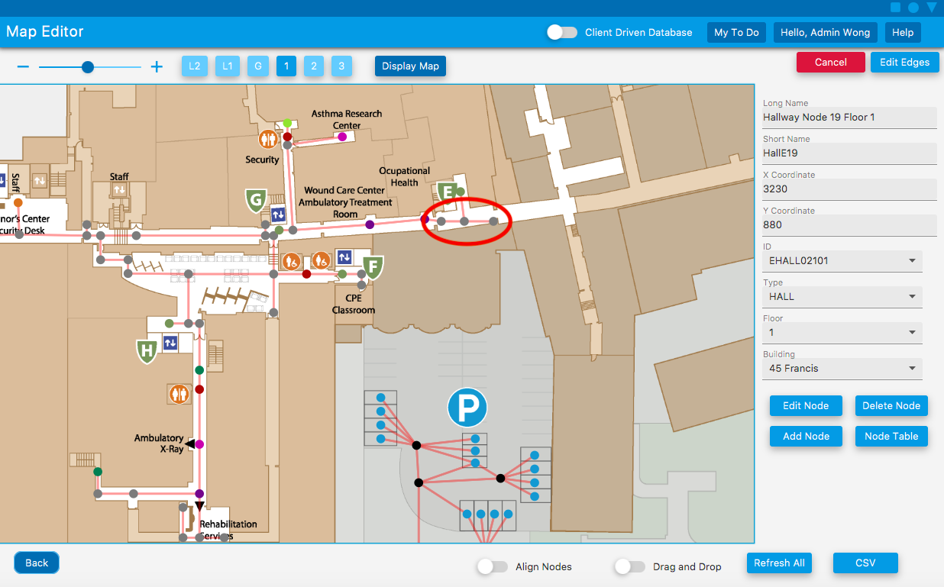

Double click on the axis you want the nodes to be aligned on, and they will automatically align.

### Align Vertically

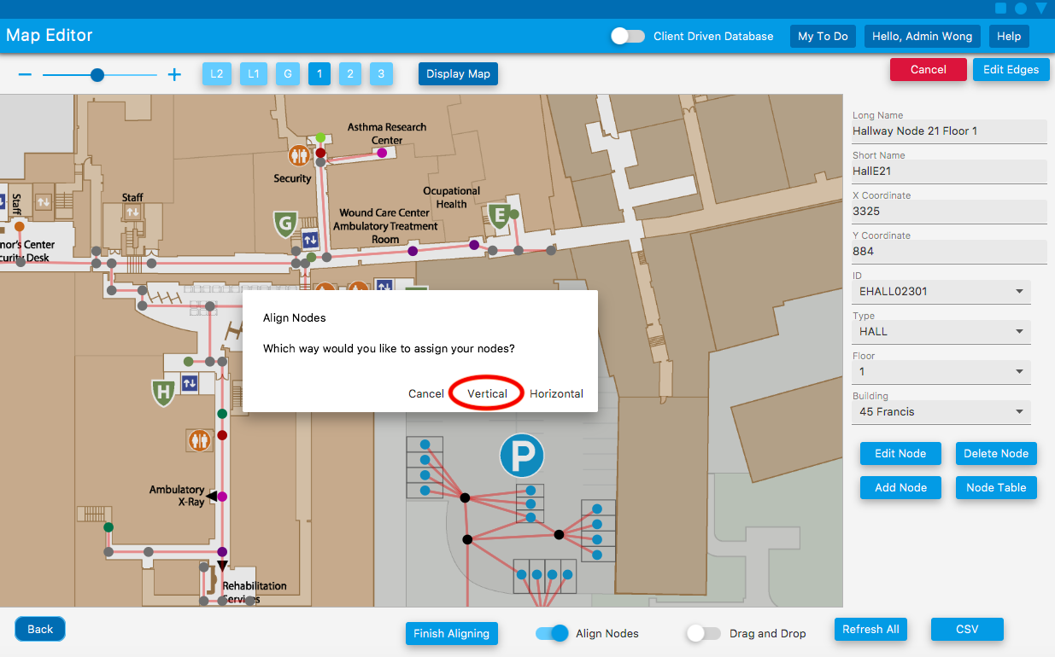

Select the **Vertical** button on the popup.



Double click on the nodes you want to align and press **Finish Aligning** button

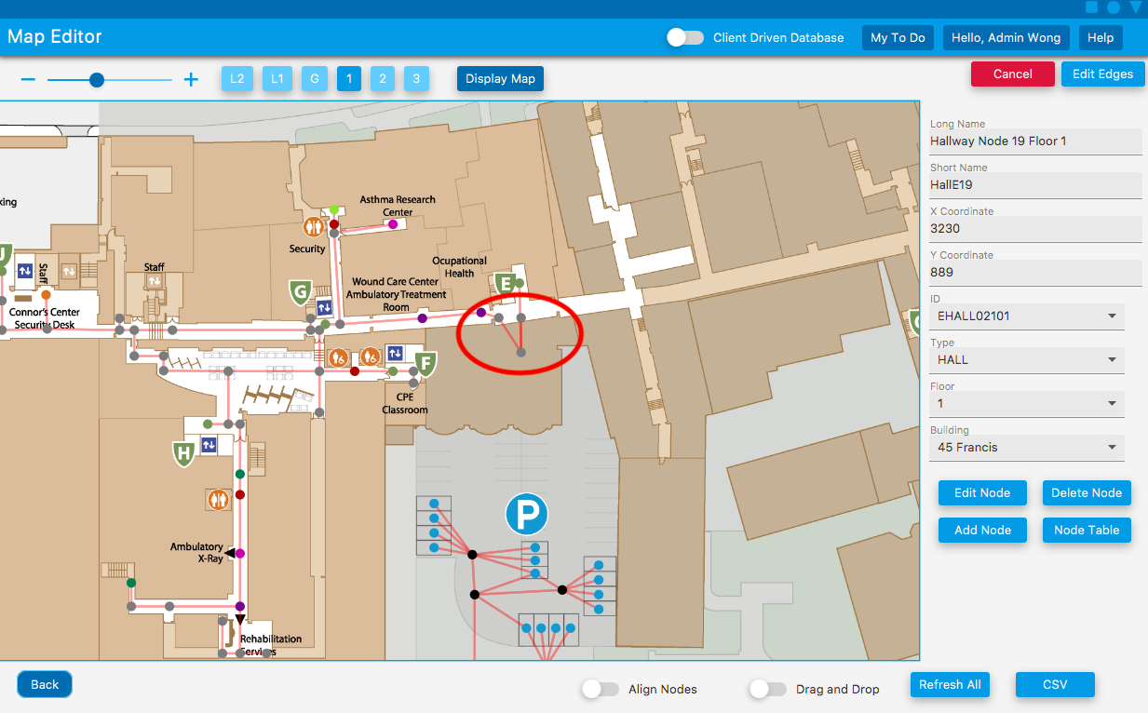

Double click on the axis you want the nodes to be aligned on, and they will automatically align.

## Edit Edges

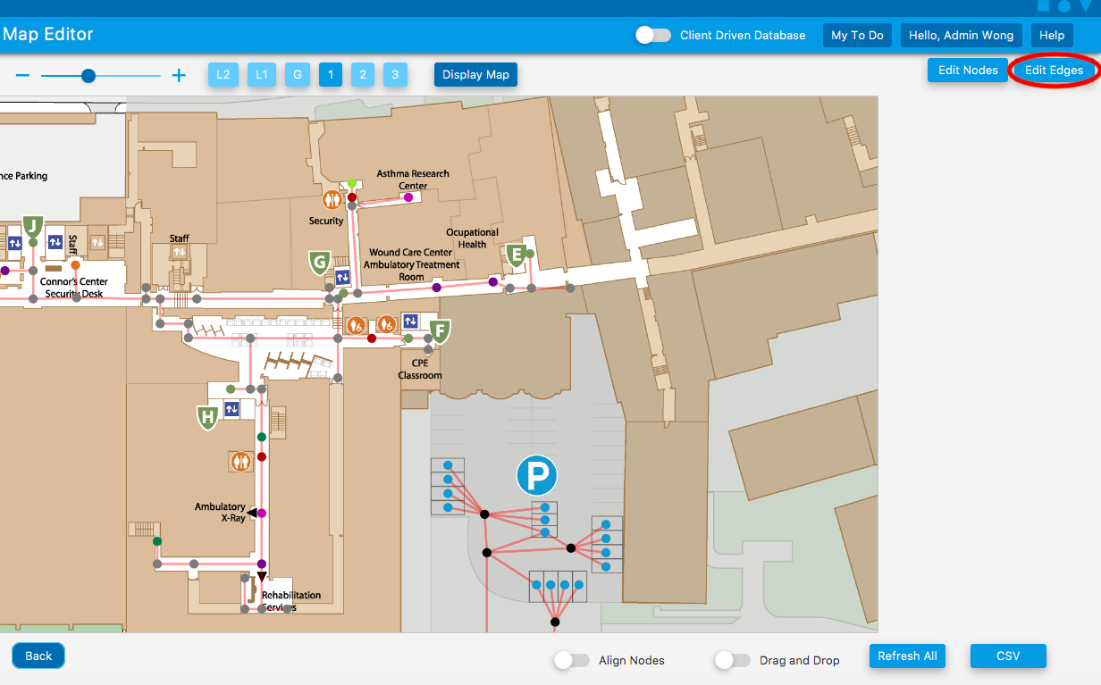

Click on the **Edit Edges** button.

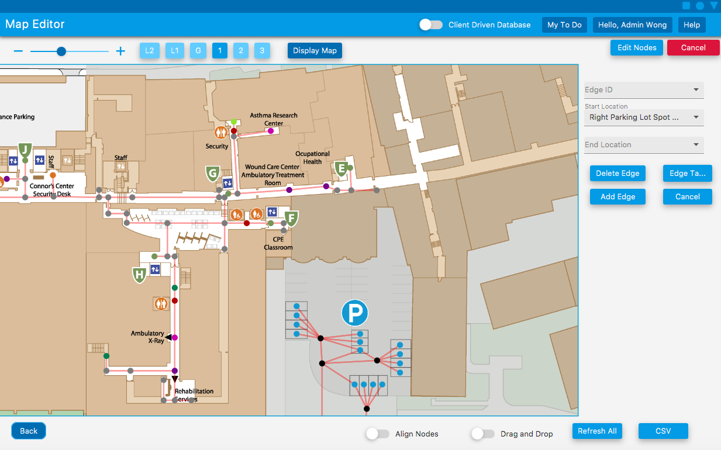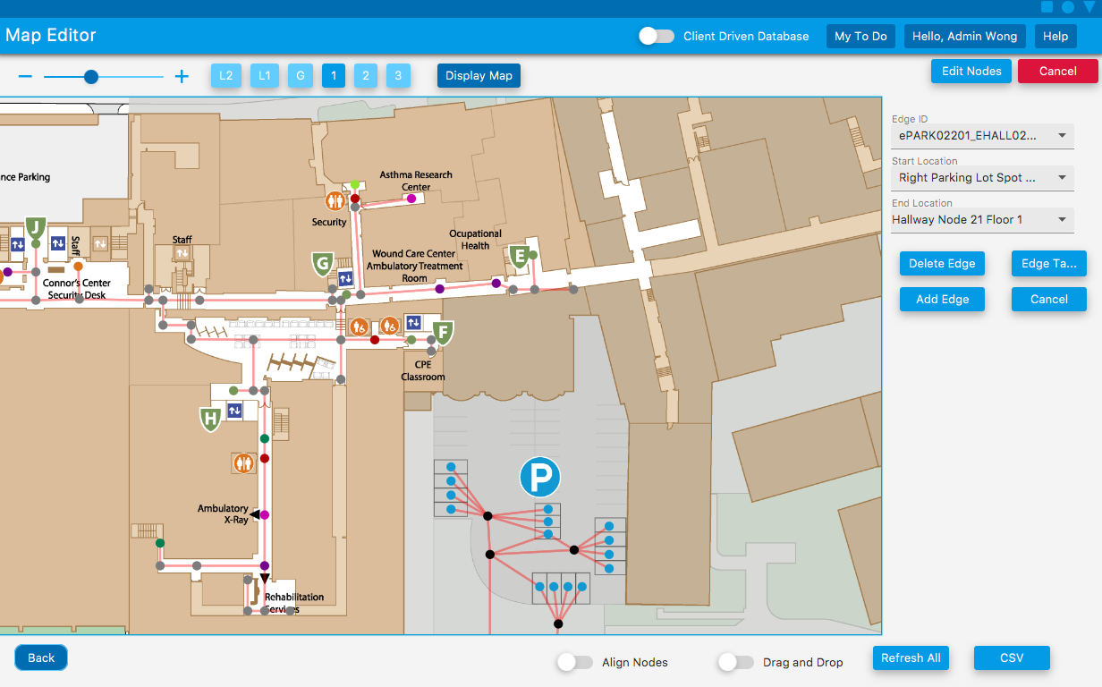

Click on the start node then the end node.

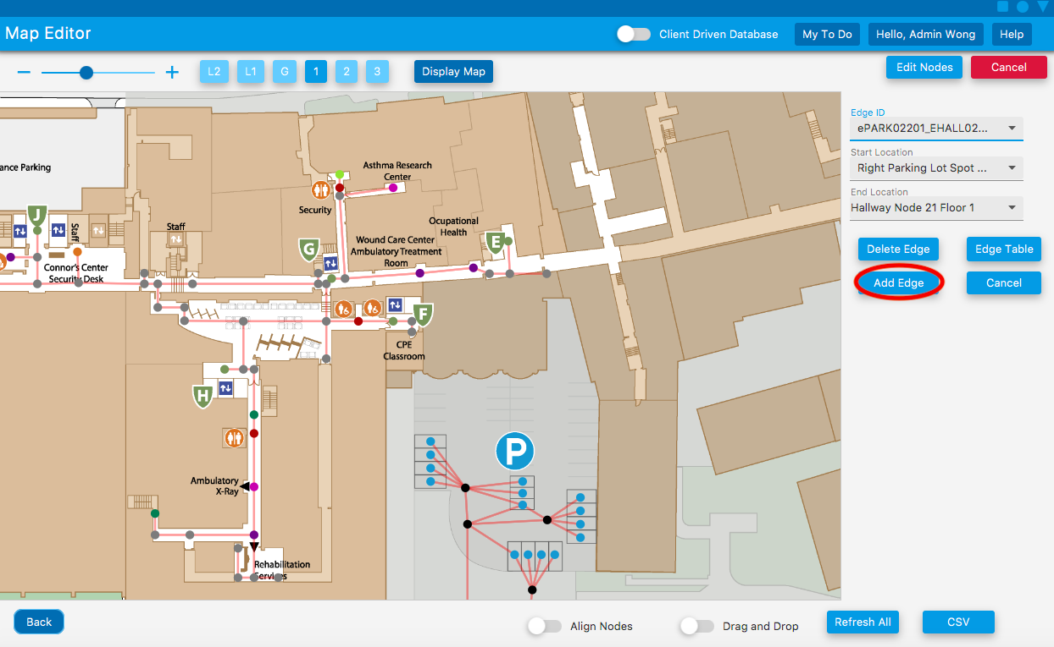

Click on the **Add Edge** button.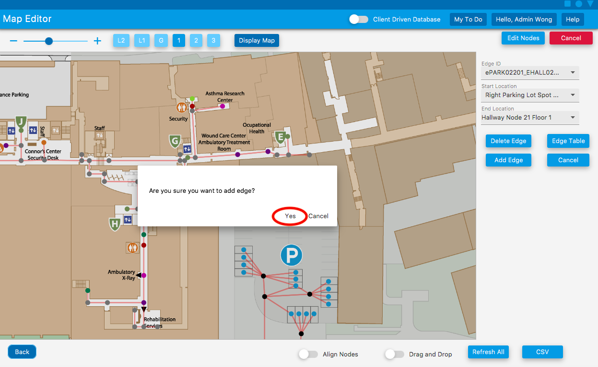

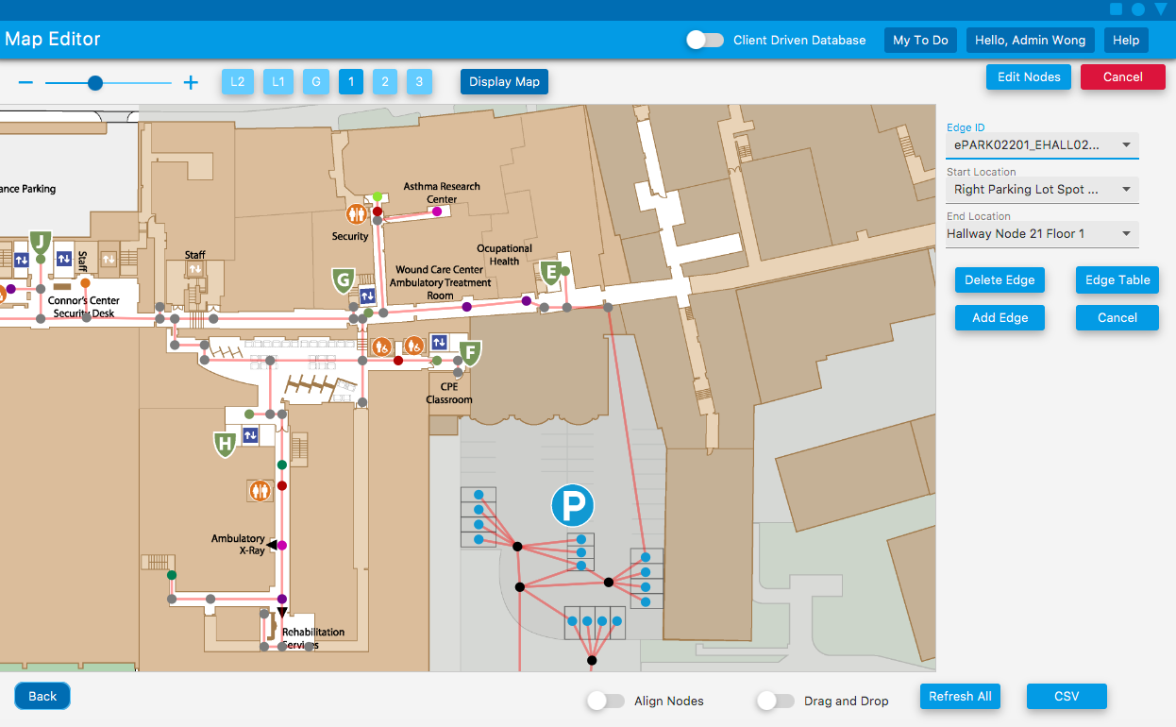

Select **Yes** on the popup and the edge should be modified.

## CSV

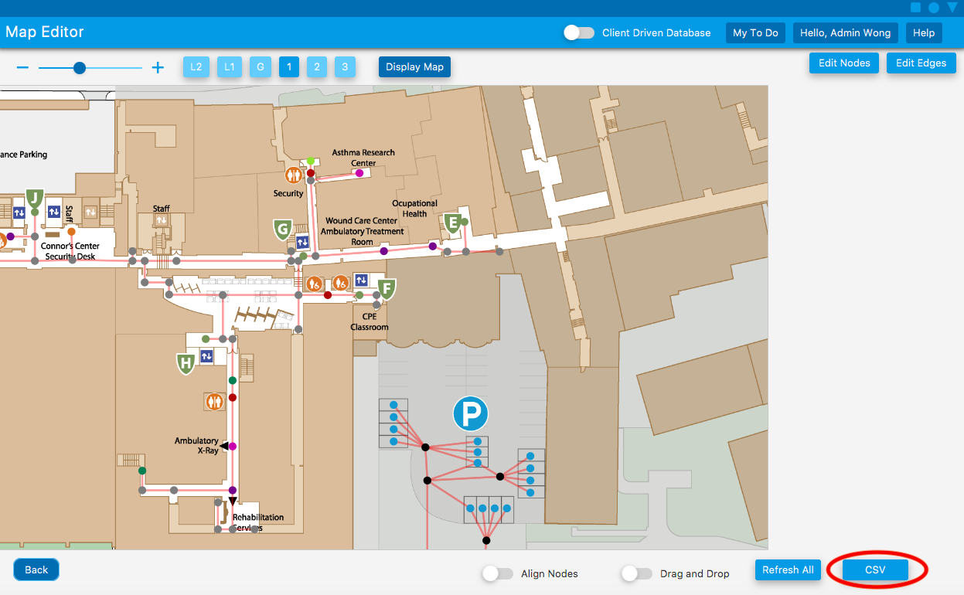

Click on the **CSV** button.

### Upload

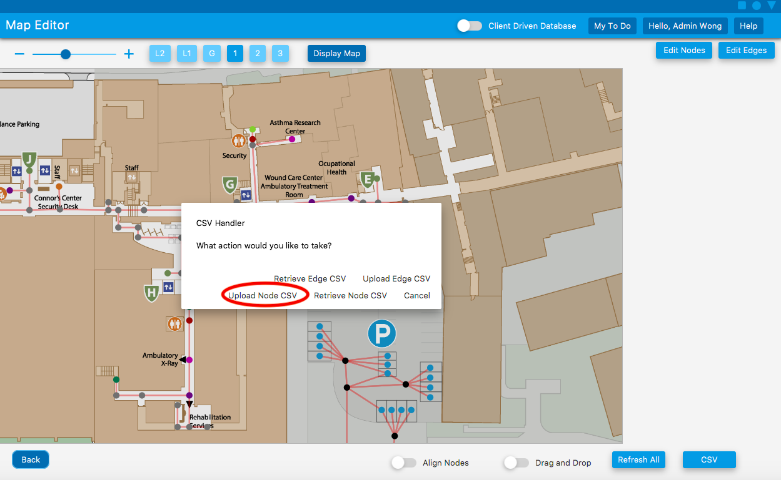

Click on **Upload CSV** on the popup.

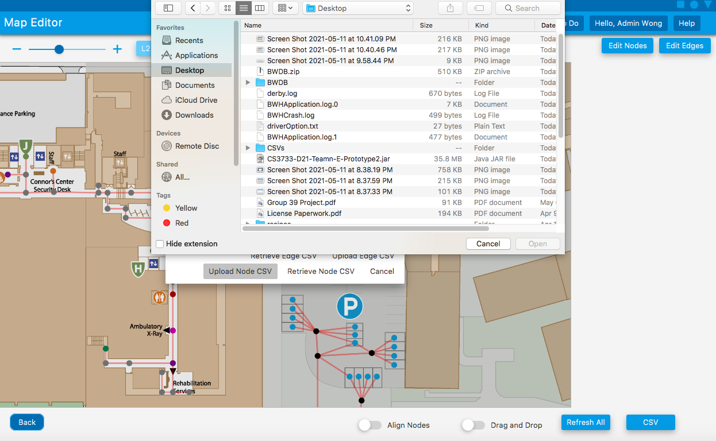

### Retrieve

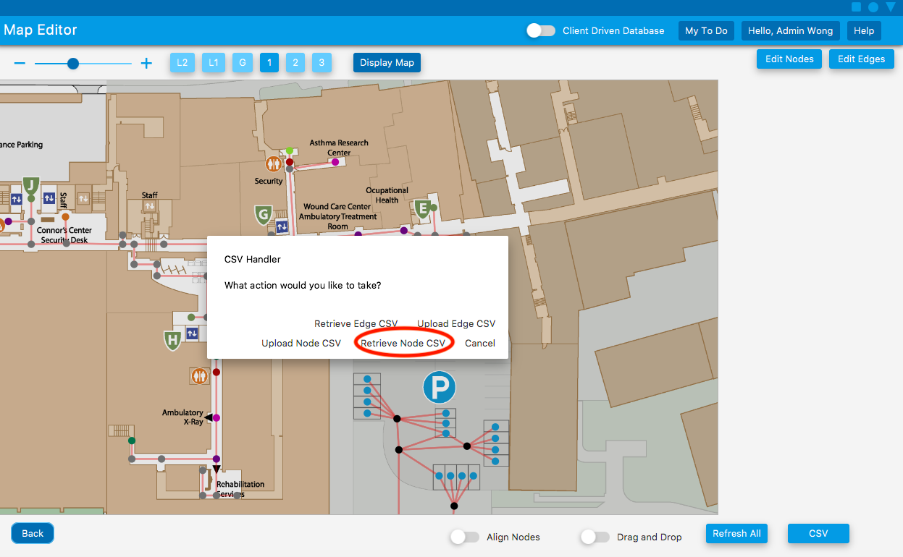

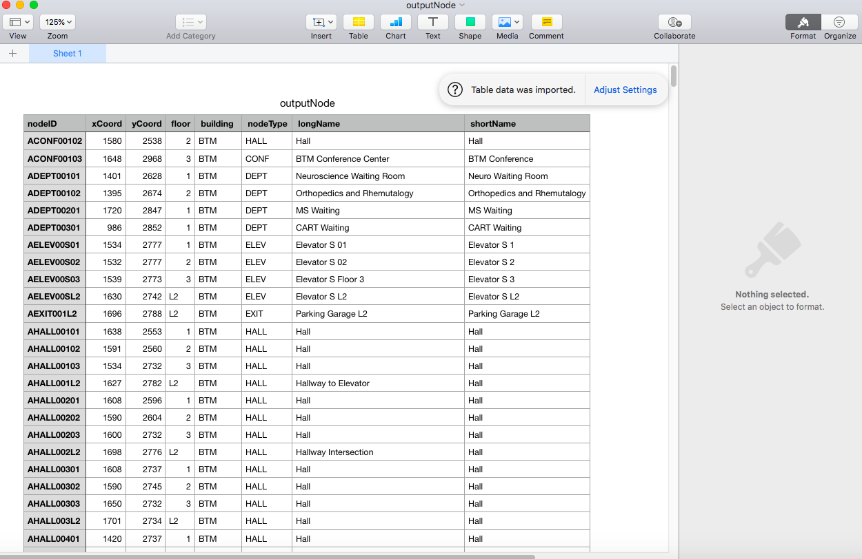

Click on **Retrieve csv** button and the currently loaded csv should pop up.

# User Management

## Add User

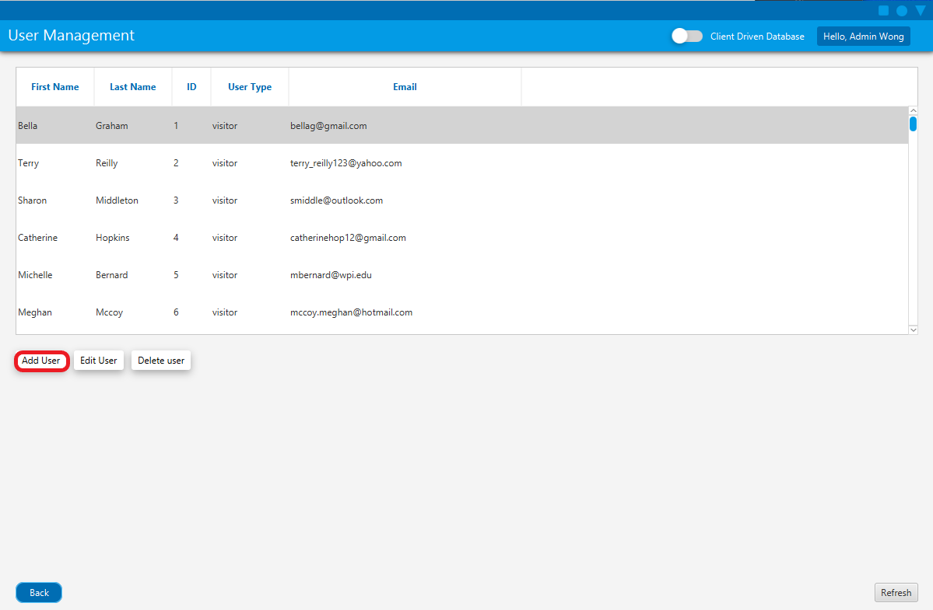

Click the **Add User** button.

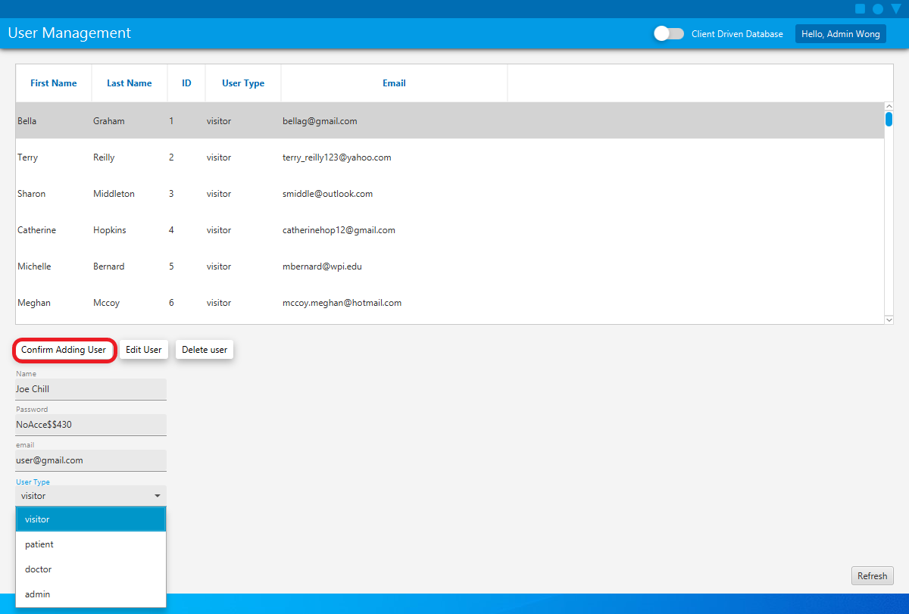

Enter appropriate inputs into the **Name, Password**and **Email fields**. For the **User Type**dropdown select the desired user type for the account being created. When finished click the **Confirm Adding User**button.

## Delete User

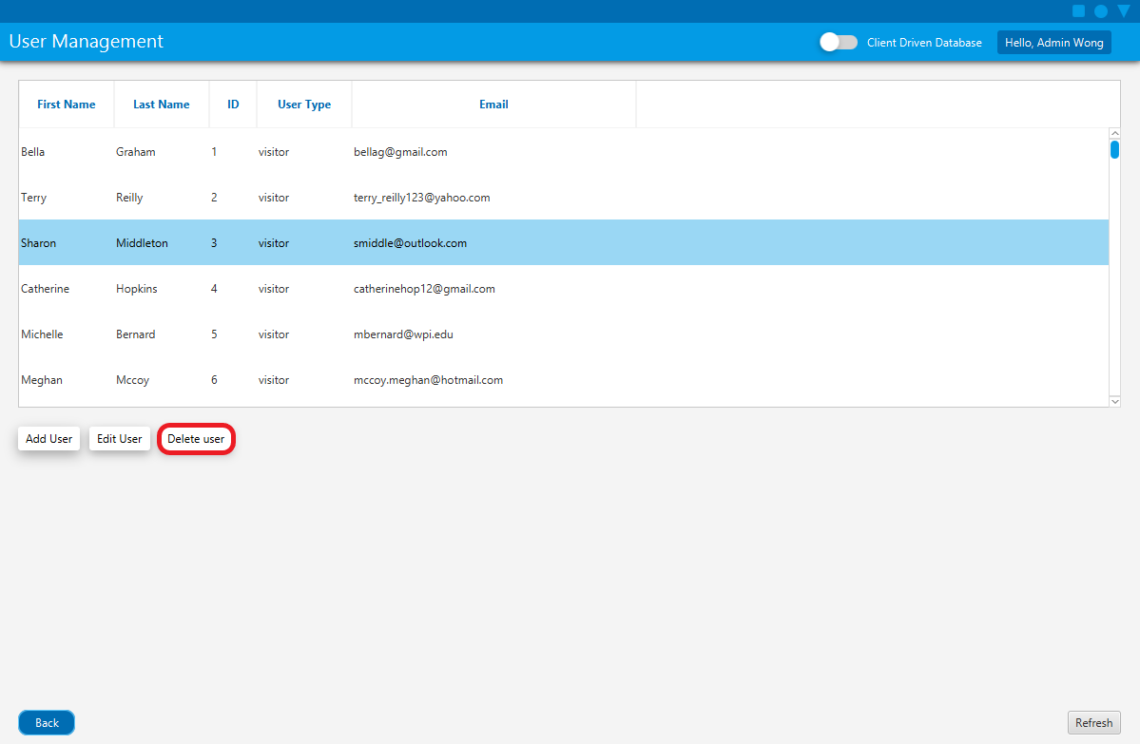

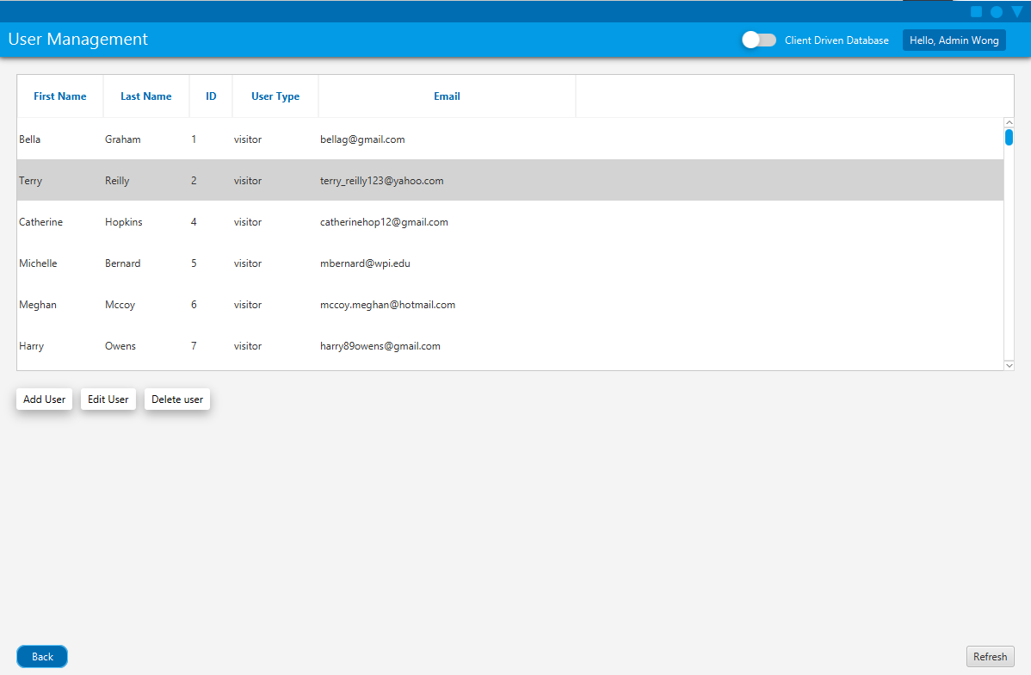

Select the user which needs to be deleted (the row will be highlighted). Click the **Delete user**button.

## Edit User

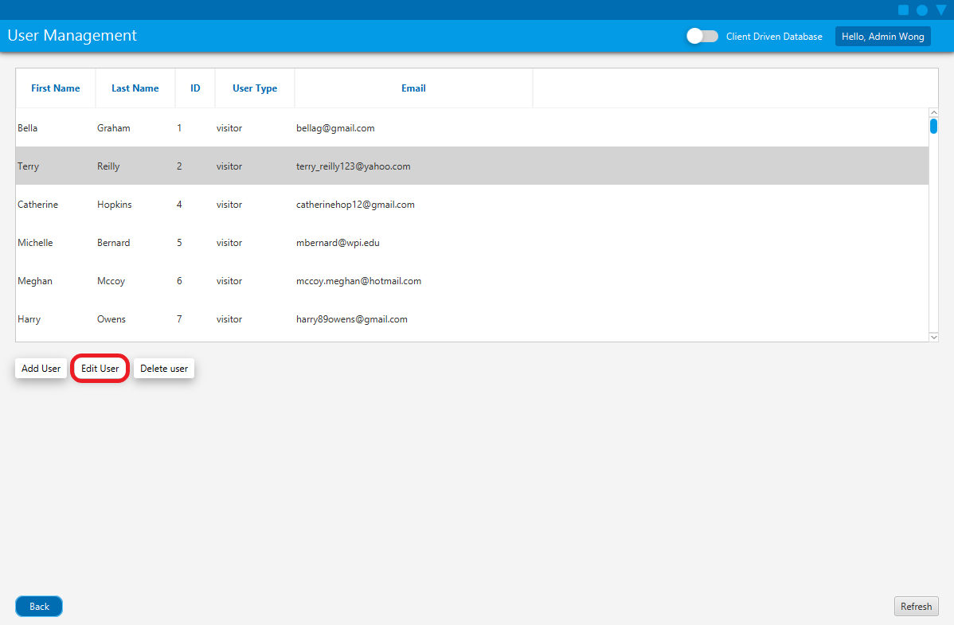

Select the user which needs to be edited (the row will be highlighted). Click the **Edit user**button.

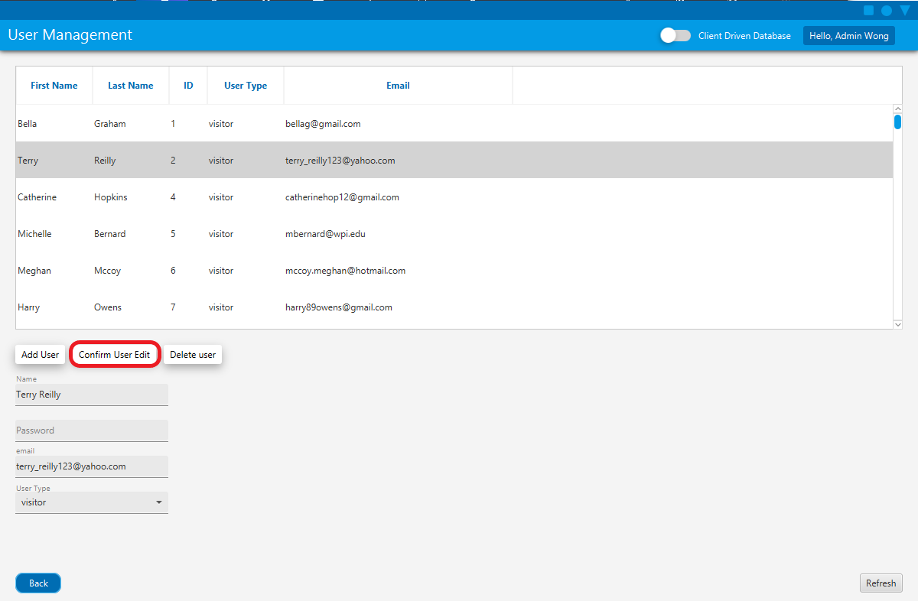

Modify the user fields as desired and then click the **Confirm User Edit.**

# Service Requests

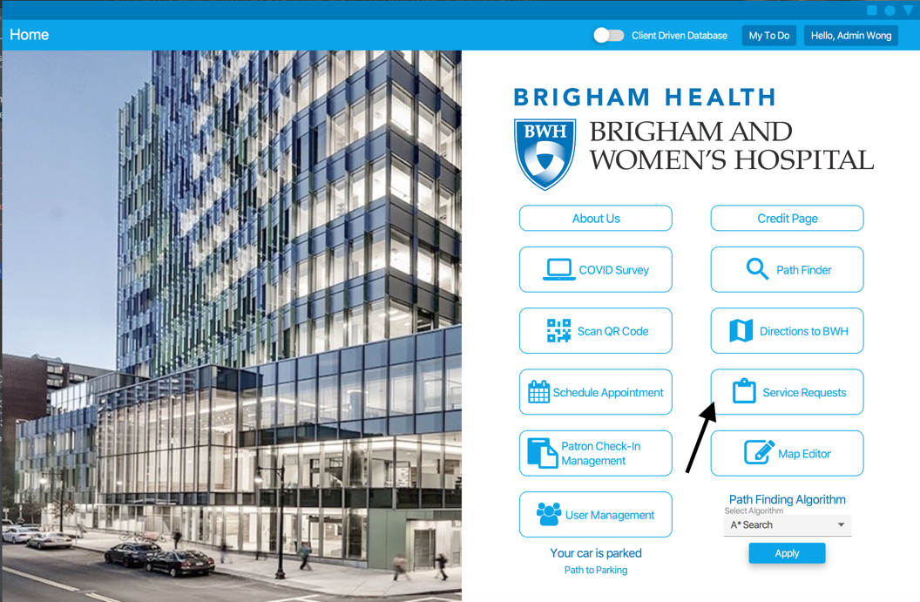

In order to submit a service request, one must be logged into the system. A normal user can only see requests related to them. Only then can one select which category best suits their need. Then select the service requests button.

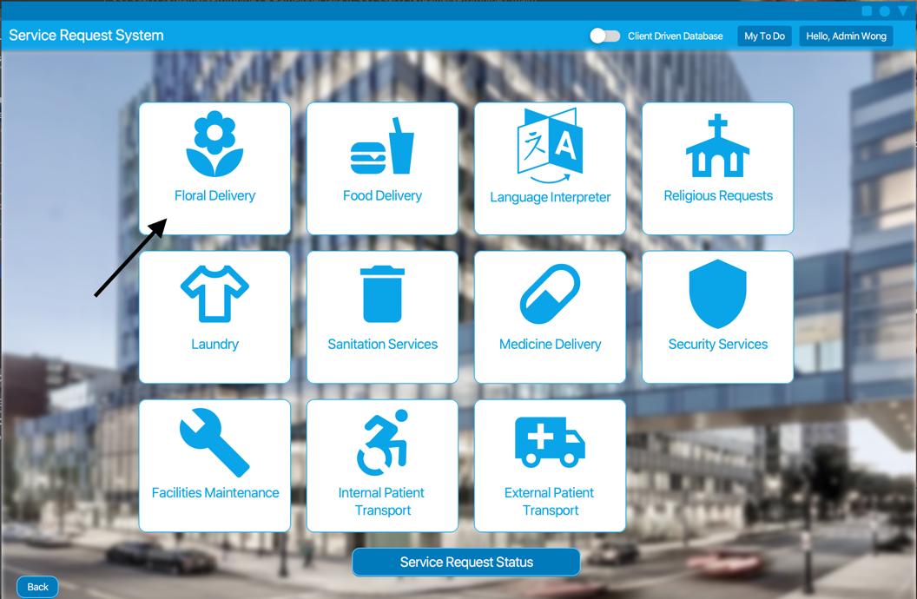

Once entered select the specific form for your service request.

## Floral Delivery

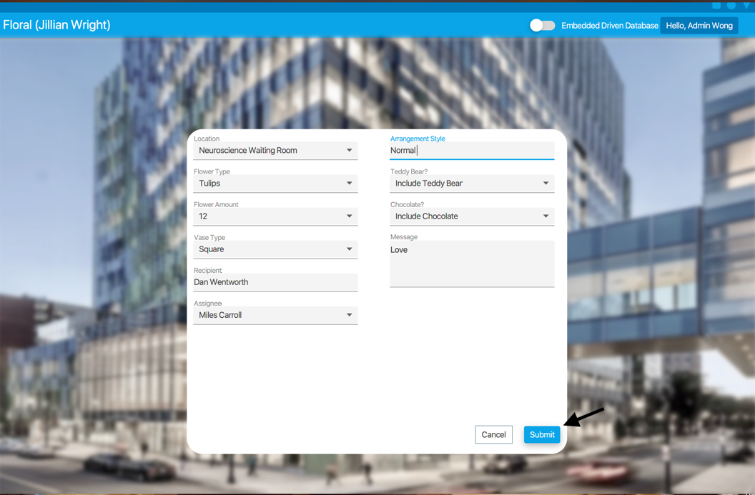

To fill out a Floral Delivery service request select the **Floral Delivery** button. Then fill in the location, the flower type, the flower amount, the vase type, the recipient of the gift, the assignee, the arrangement style, an answer yes/no to teddy bear, an answer yes/no to chocolate, and a message. Once the information is completed press submit to finish the service request.

## Food Delivery

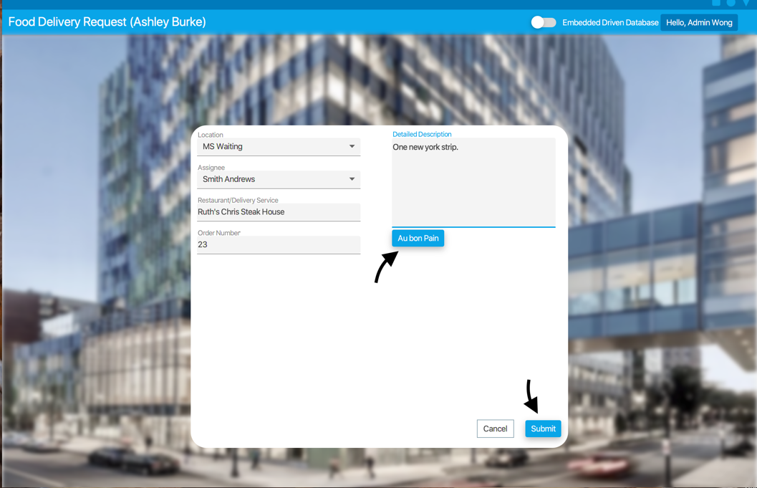

To fill out a Food Delivery service request select the **Food Delivery** button. Then fill in a location, the assignee, the restaurant and/or delivery service being used and a detailed description. Once the information is completed press submit to finish the service request.

### Au Bon Pain Page

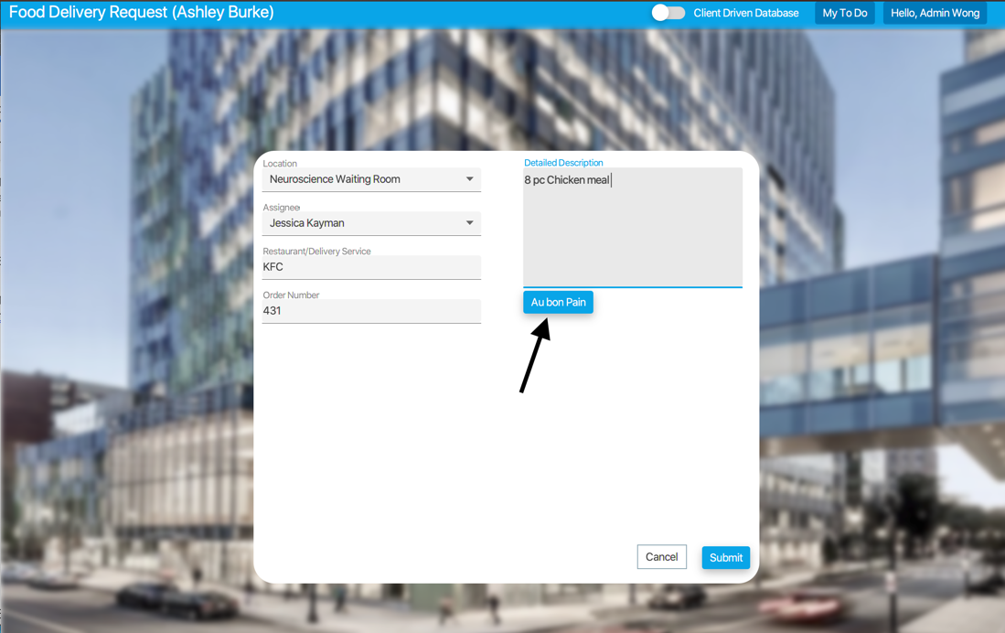

To access this page, first fill out a Food Delivery To find out more information about what to order, click the **Au Bon Pain** button. Here you can scroll and order food from the Au Bon Pain within the hospital.

. 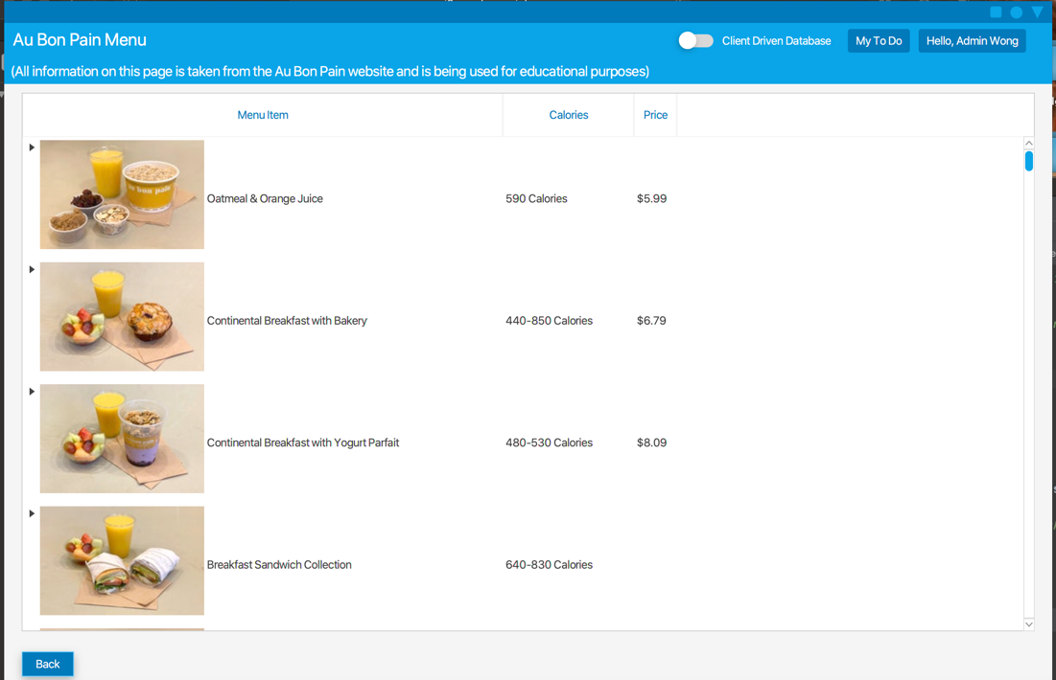

## Language Interpreter

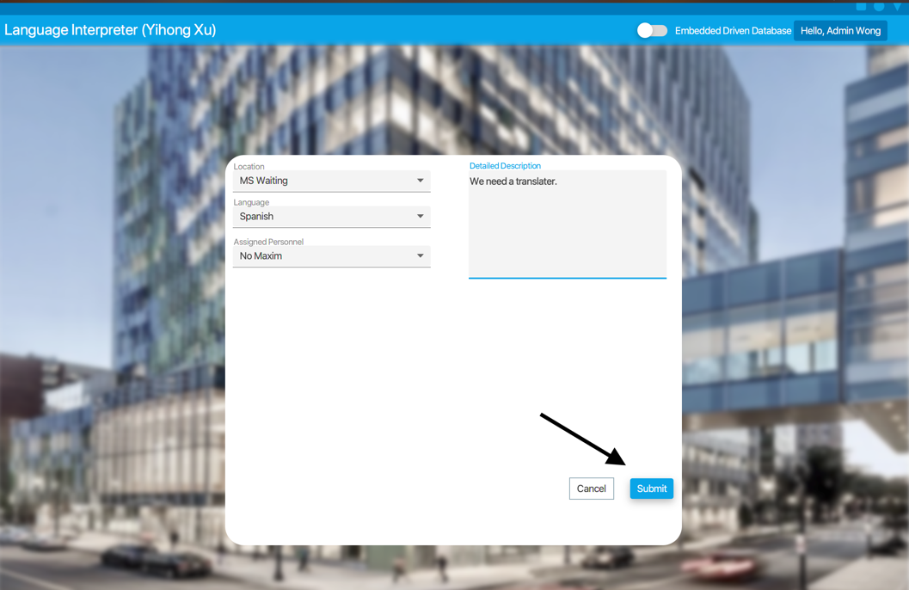

To fill out a Language Interpreter service request select the **Language Interpreter** button and fill in a location, a language, the assigned personnel, and the detailed description. Once the information is completed press submit to finish the service request.

## Religious Request

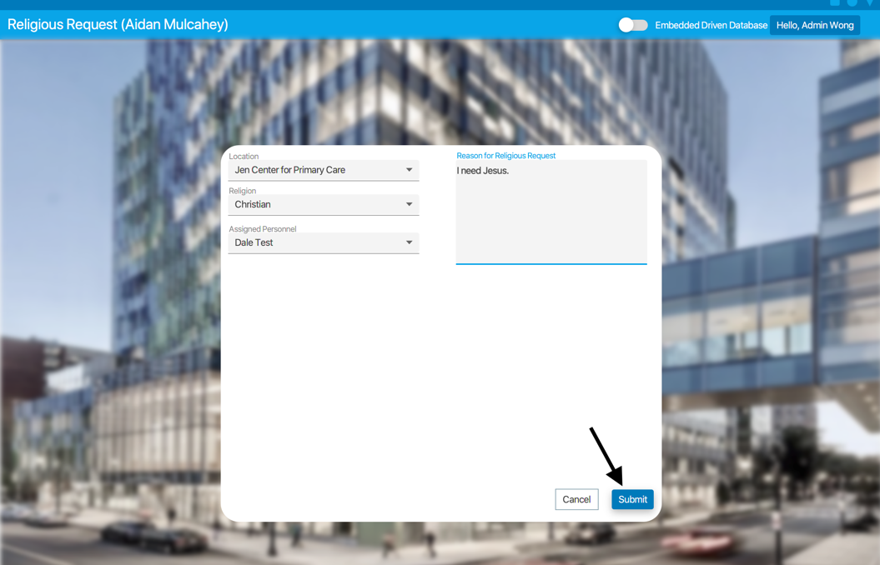

To fill out a Religious Service Requests form first select the **Religious Requests** button and fill in the location, the religion, the assigned personnel, and the reason for the religious request. Once the information is completed press submit to finish the service request.

## Laundry Request

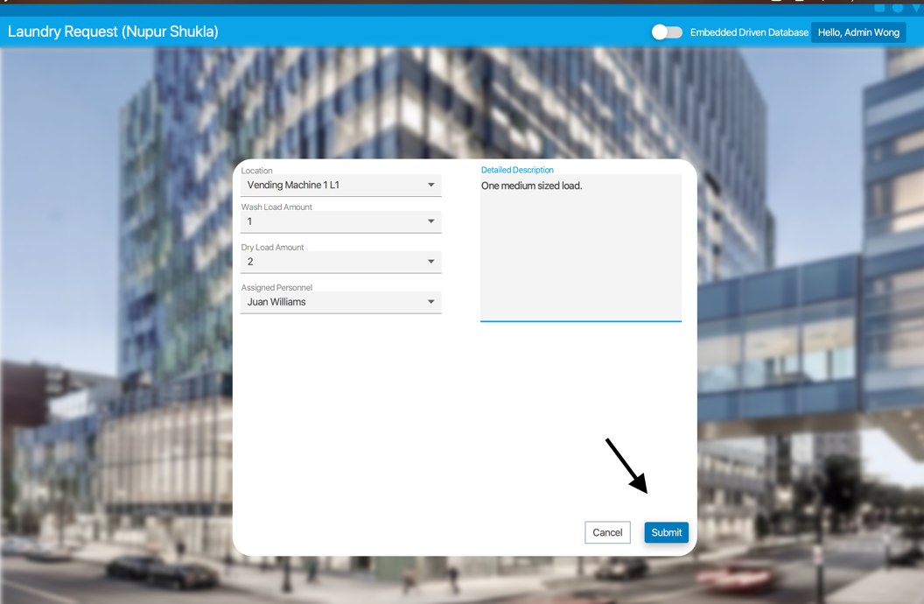

To fill out a Laundry Services Request form first select the **Laundry Button** and fill in the location, the wash load amount, the dry load amount, the assigned personnel, and a detailed description. Once the information is completed press submit to finish the service request.

## Sanitation Request

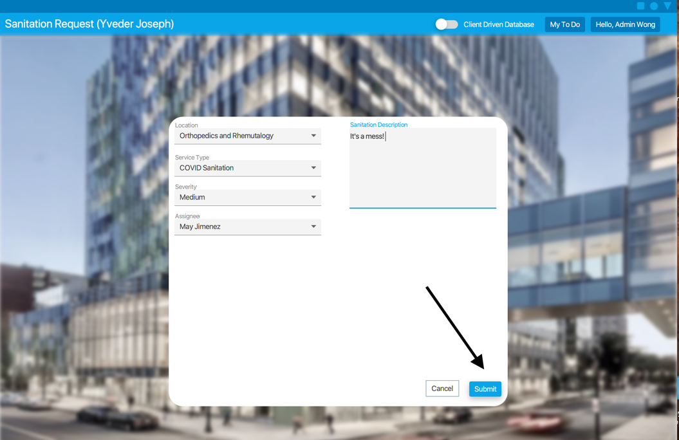

To fill out a Sanitation Services form first select the **Sanitation Services** button and then fill in the location, the service type, the severity of the issue, the assignee of the request, and a sanitation description. Once the information is completed press submit to finish the service request.

## Medicine Delivery

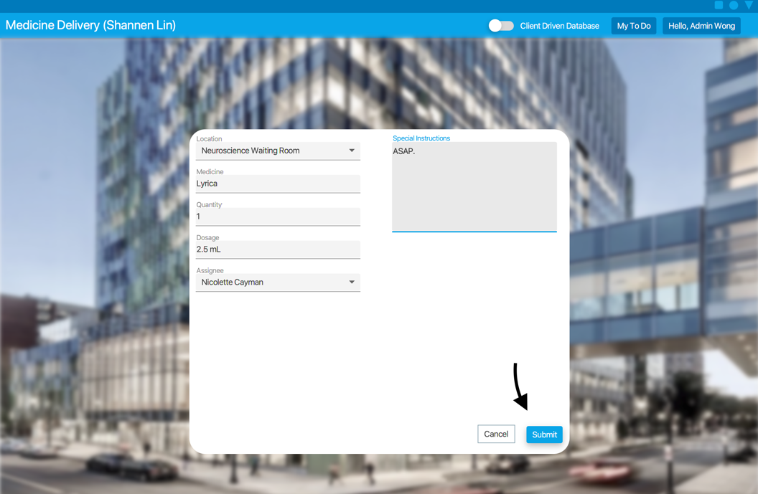

To fill out a Medicine Delivery form select the **Medicine Delivery** button, then fill in a location, the medicine being used, the quantity of medicine, the dosage, the assigned personnel, and the special instructions for the request. Once the information is completed press submit to complete the service request.

## Security Services

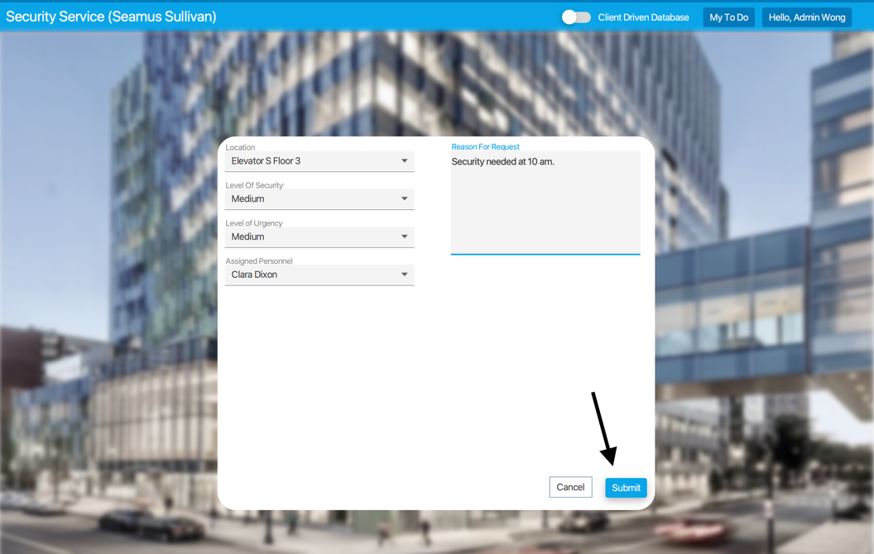

To fill out a Security Services form first select the **Security Services** button, then fill in a location, a level of security, level of urgency, the assigned personnel, and the reason for the request. Once the information is completed press submit to complete the service request.

## Facilities Maintenance

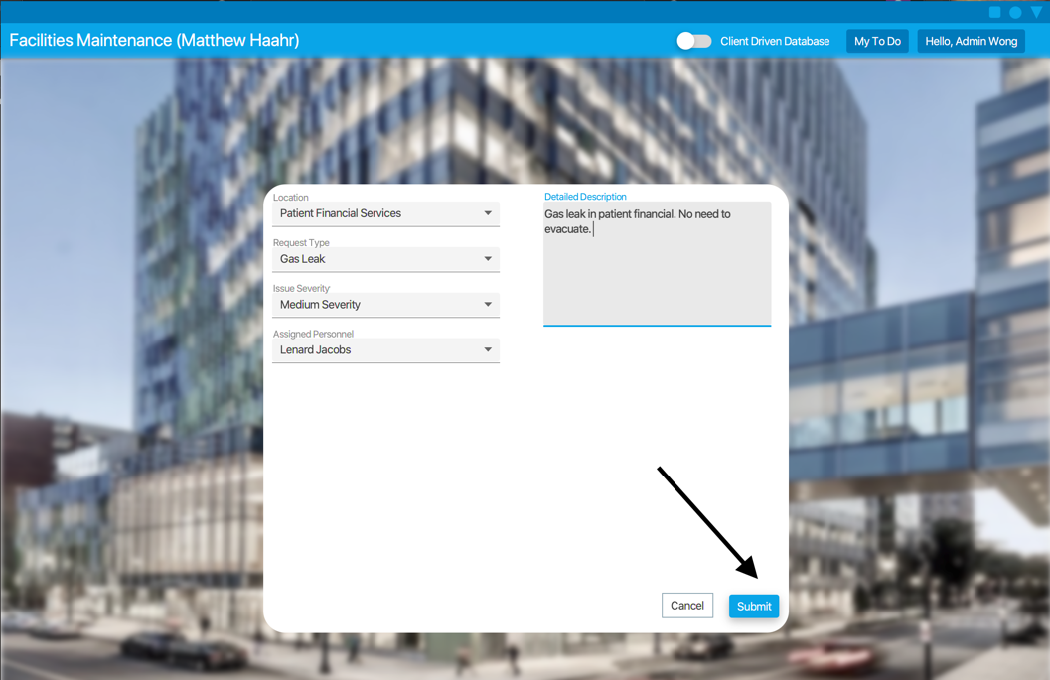

To fill out a Facilities Maintenance form first select the **Facilities Maintenance** button, fill in a location, a request type, the issue severity, the assigned personnel, and a detailed description. Once the information is completed press submit to complete the service request.

## Internal Patient Transport

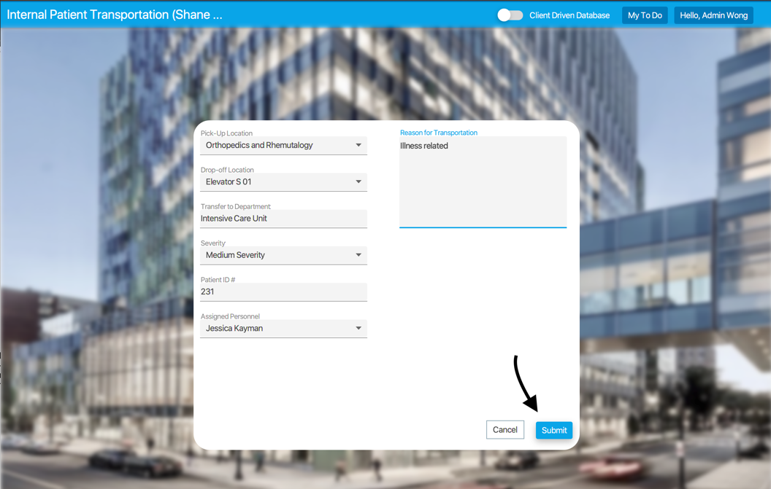

To fill out an Internal Patient Transport first select the **Internal Patient** **Transport** Button fill in a pick-up location, a drop-off location, mention department patient is being transported to, severity, patient ID #, the assigned personnel, and reason for transportation. Once the information is completed press submit to complete the service request.

## External Patient Transport

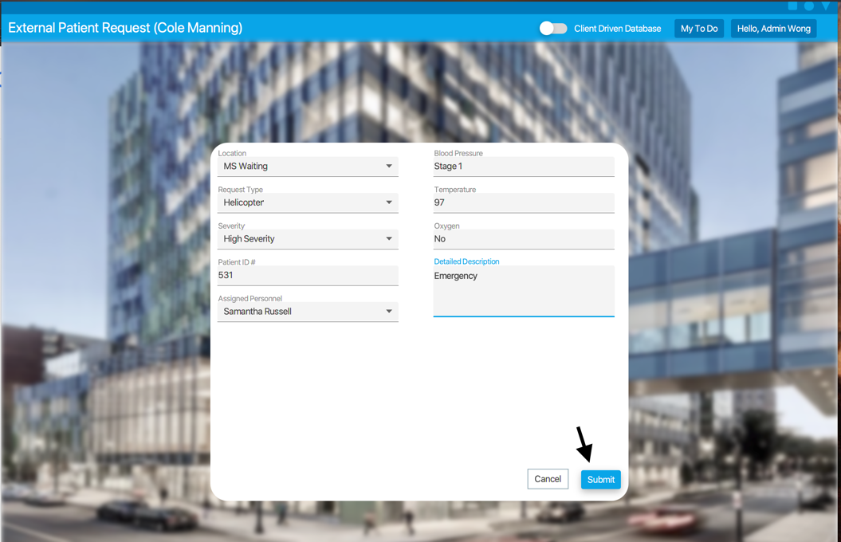

Click on External Patient Transport to fill out an **External Patient Transport** Service Request. Once in, fill in a location, a request type, severity, patient ID #, the assigned personnel, blood pressure, temperature, oxygen, and detailed description. Once the information is completed press submit to complete the service request.

## Service Request Status

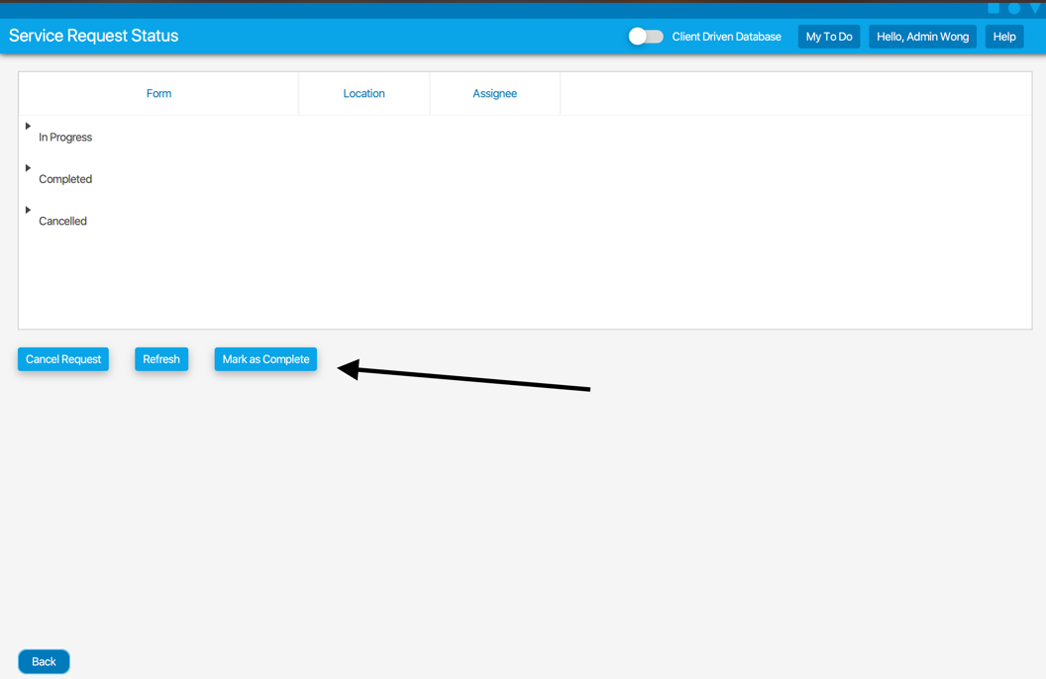

To check the status of the service requests, press the **Service Request Status Button** at the bottom of the page to view requests in progress and those that are completed or cancelled. This is a directory where you can cancel the request, refresh the table, and mark the service requests as complete. Each request has a location and an assignee.

# To-Do Scheduler

## Create Custom Task

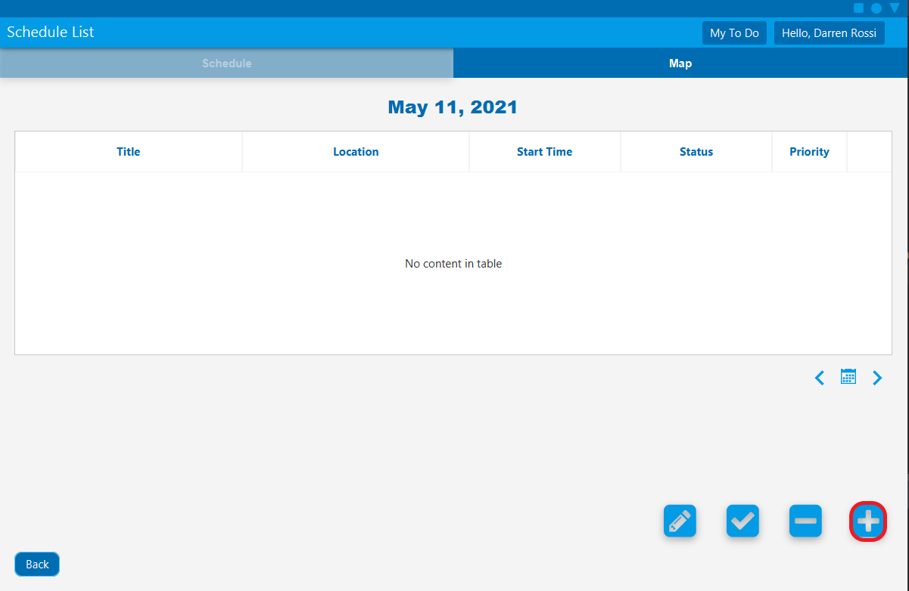

Select the **Add Custom To-Do** button.

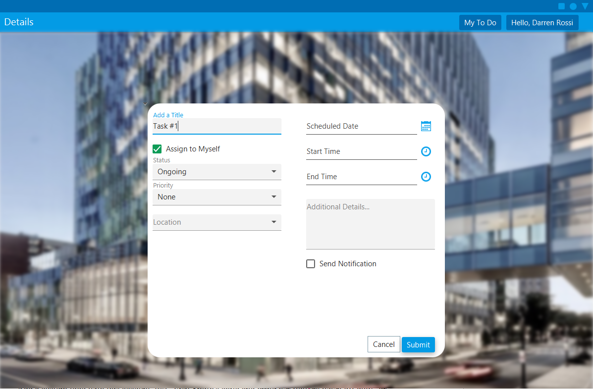

[Required] Fill out to-do Title.

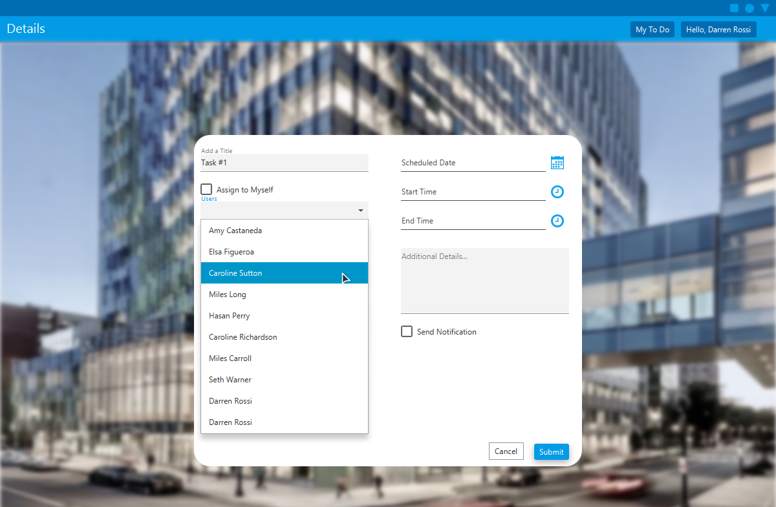

[Optional] To assign a to-do item to your co-workers, uncheck the **Assign to Myself** checkbox to see the list of your co-workers. Select the person you want to assign this task to.

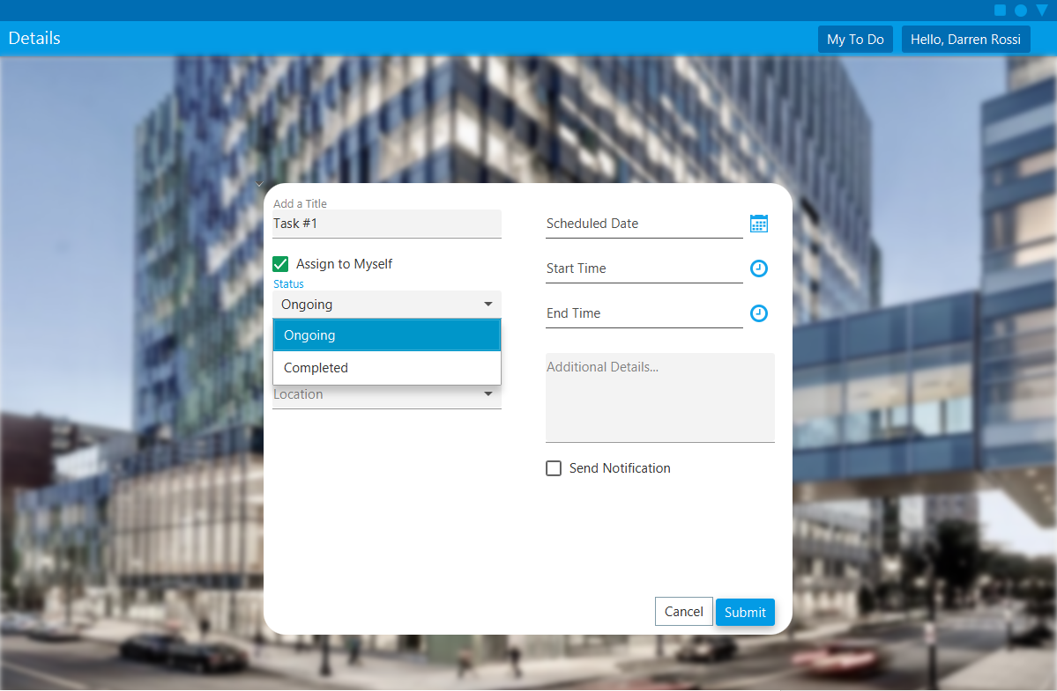

[Optional] Select Status.

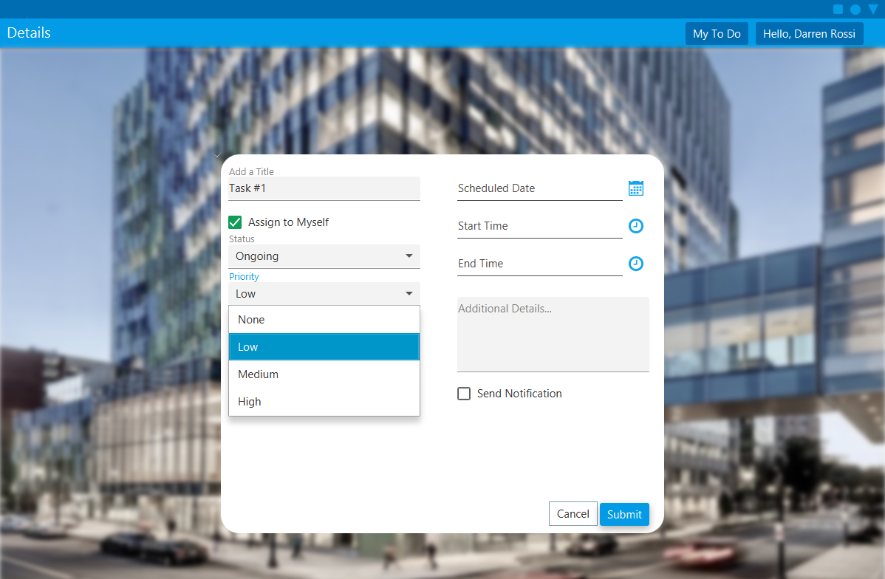

[Optional] Select priority.

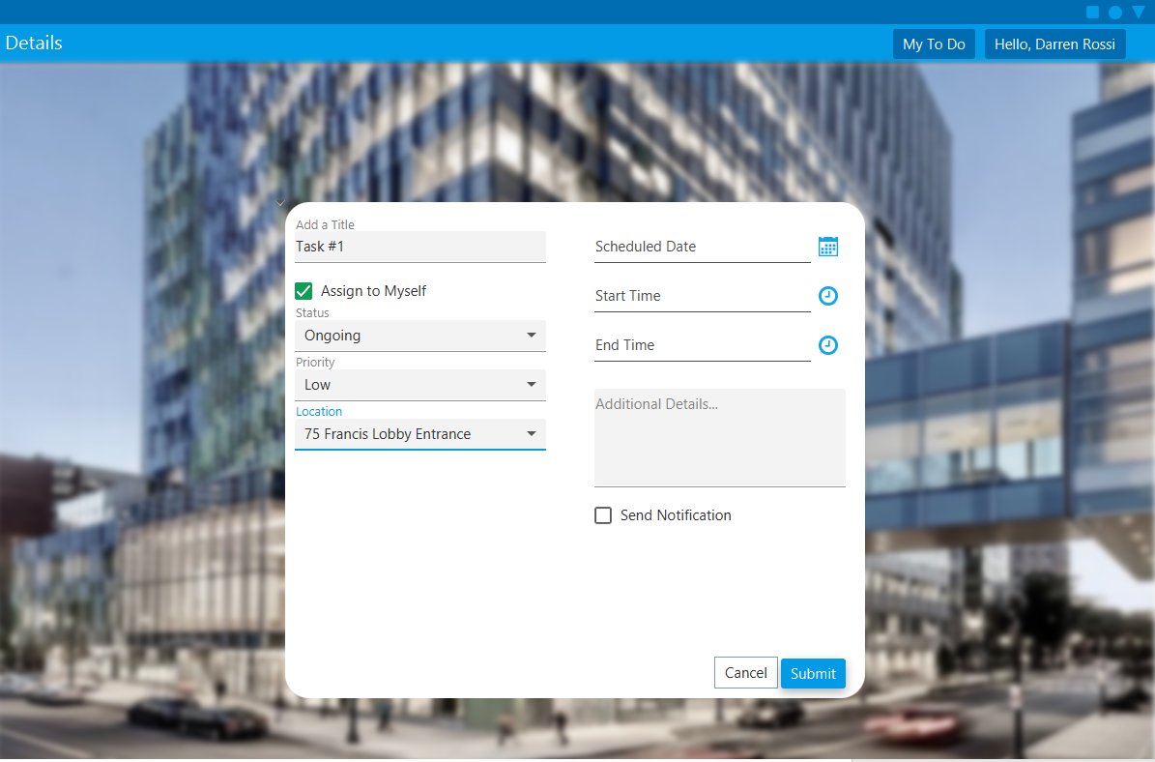

[Optional] Select location.

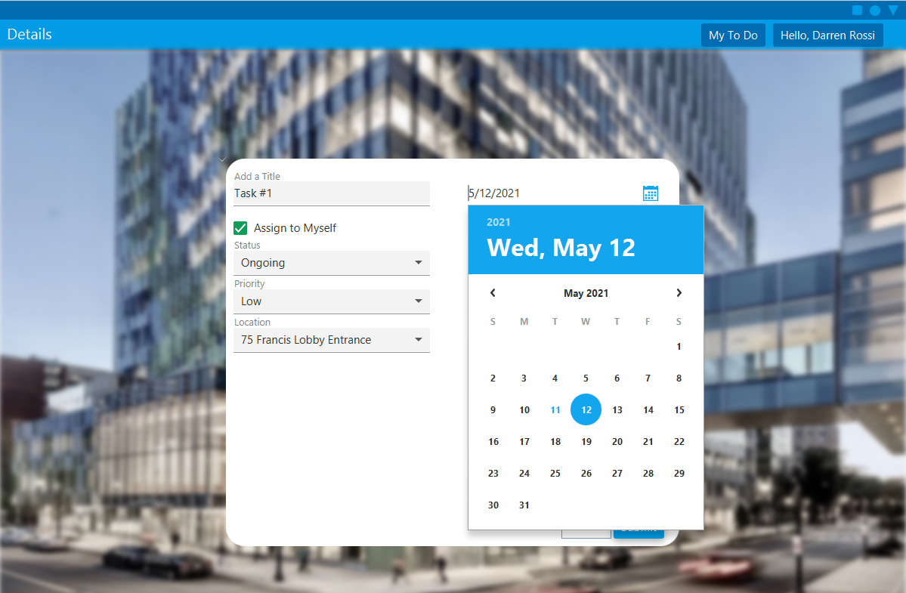

[Optional] Select the planned date.

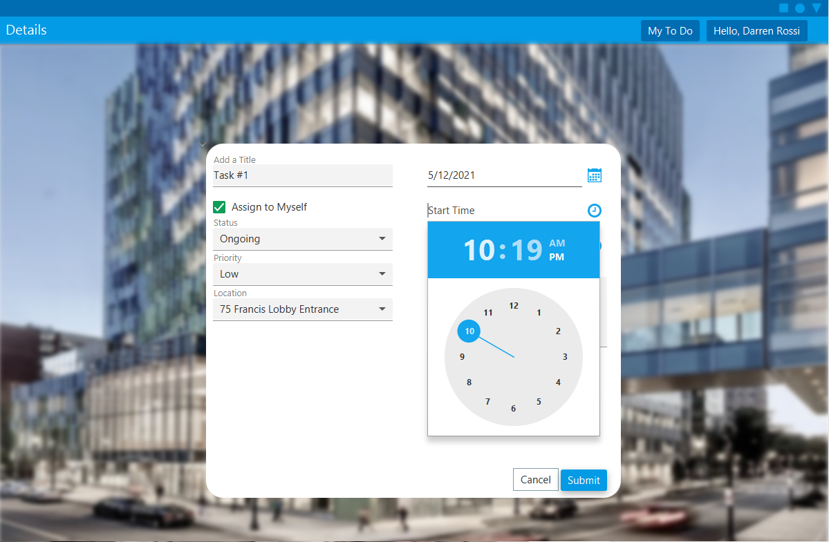

[Optional] Select planned start time.

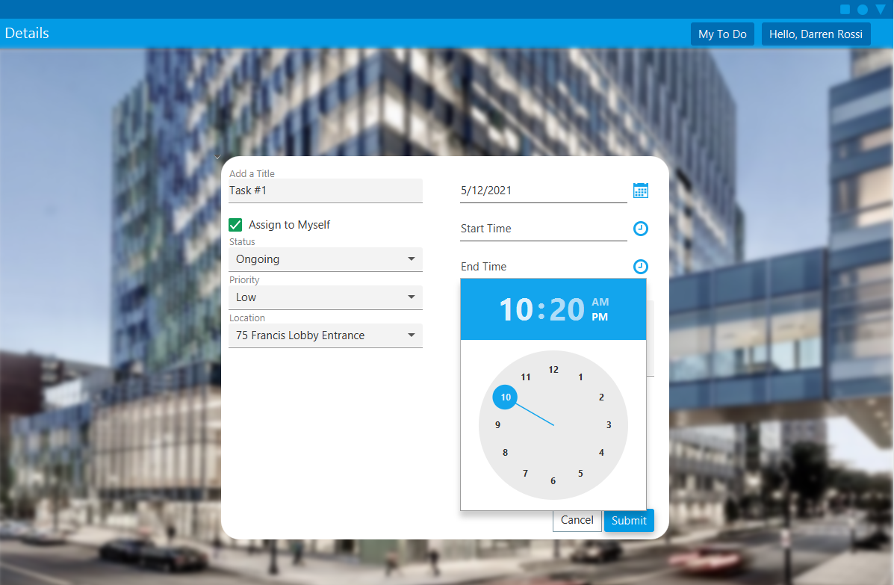

[Optional] Select projected end time.

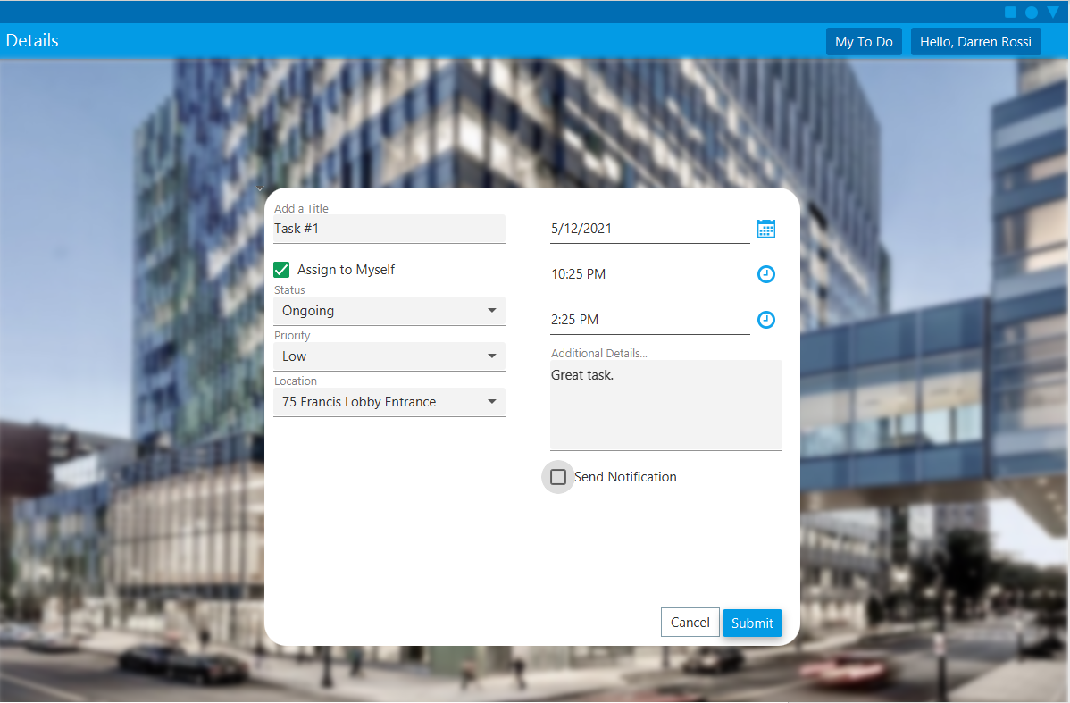

[Optional] Add notes or descriptions to **Additional Details**.

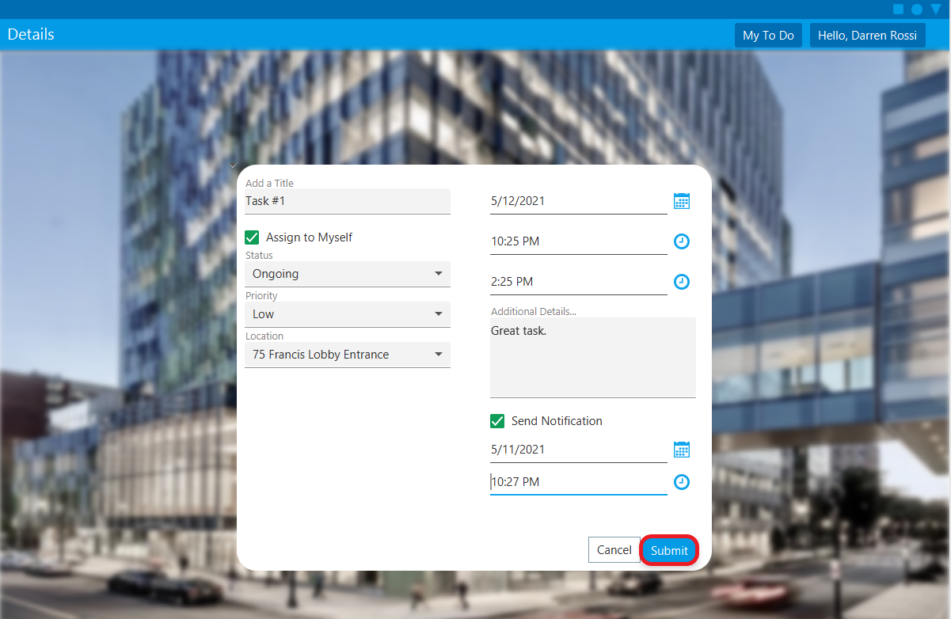

[Optional] Select **Send Notification** and select the date and time you want to receive the notification.

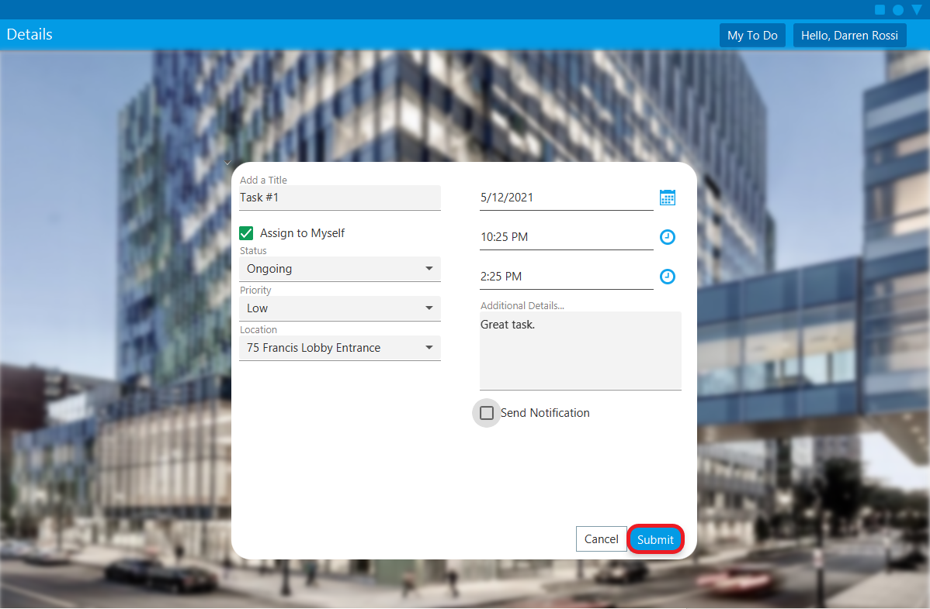

Click **Submit**.

## Edit task or view task details

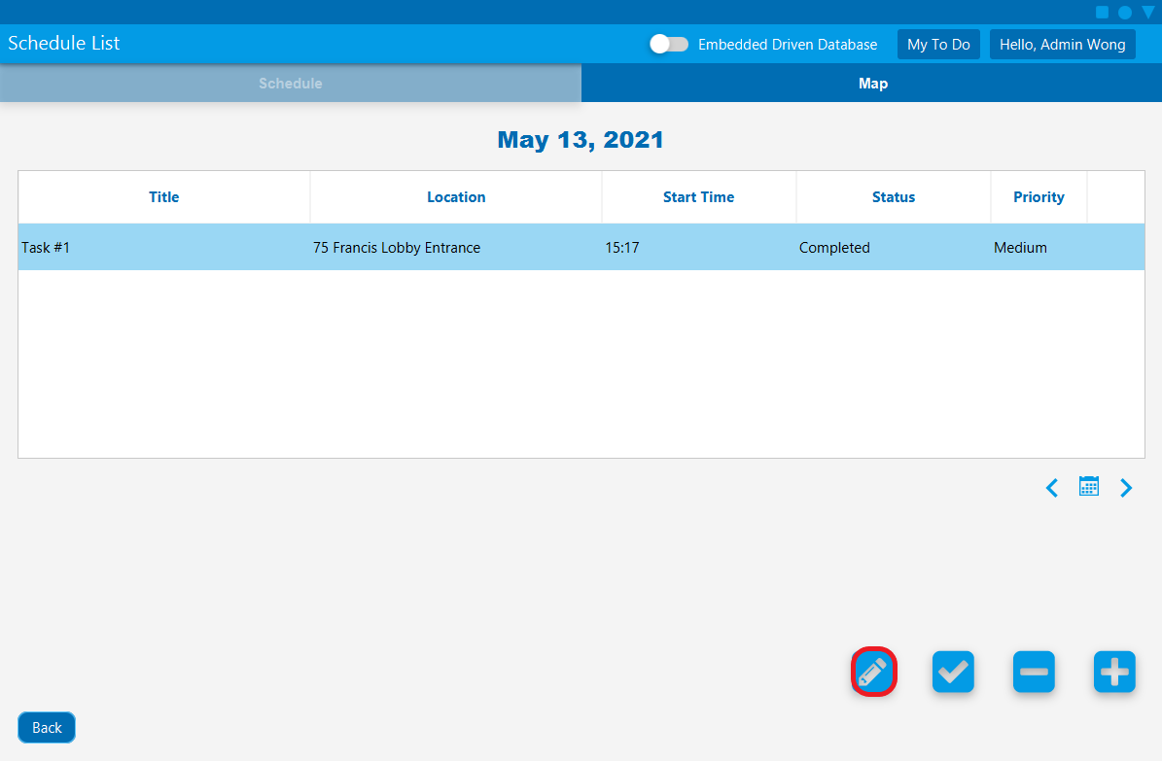

Select the **edit to-do** button to edit a to-do or view its full details.

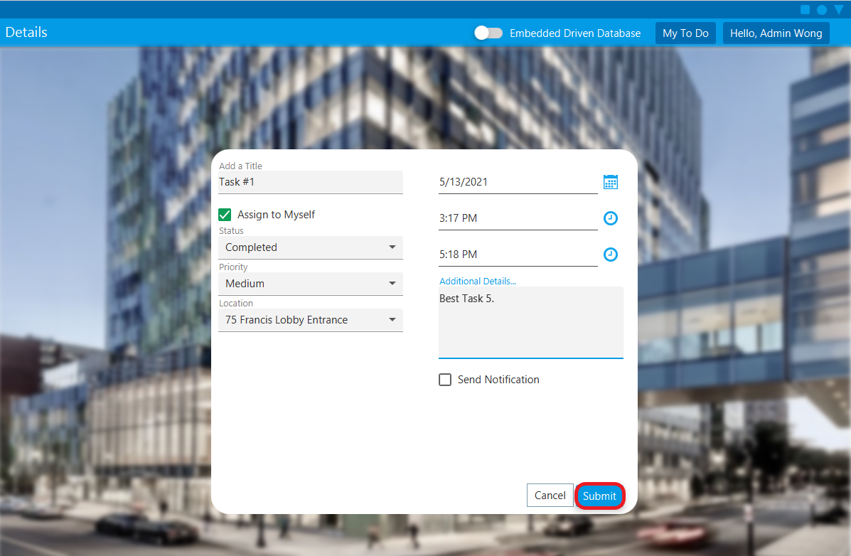

[Optional] Edit the desired fields and click the **Submit** button.

## Mark task as completed/ongoing

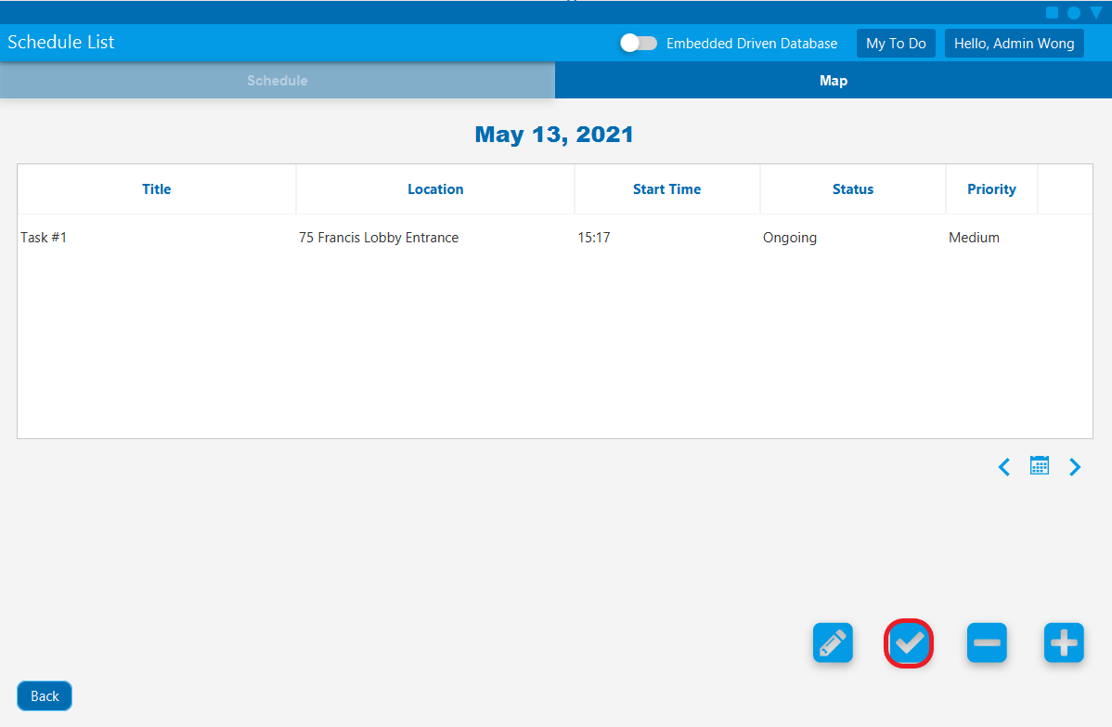

Select a to-do item and click the **check** button to mark ongoing to-do as complete or completed to-do as ongoing.

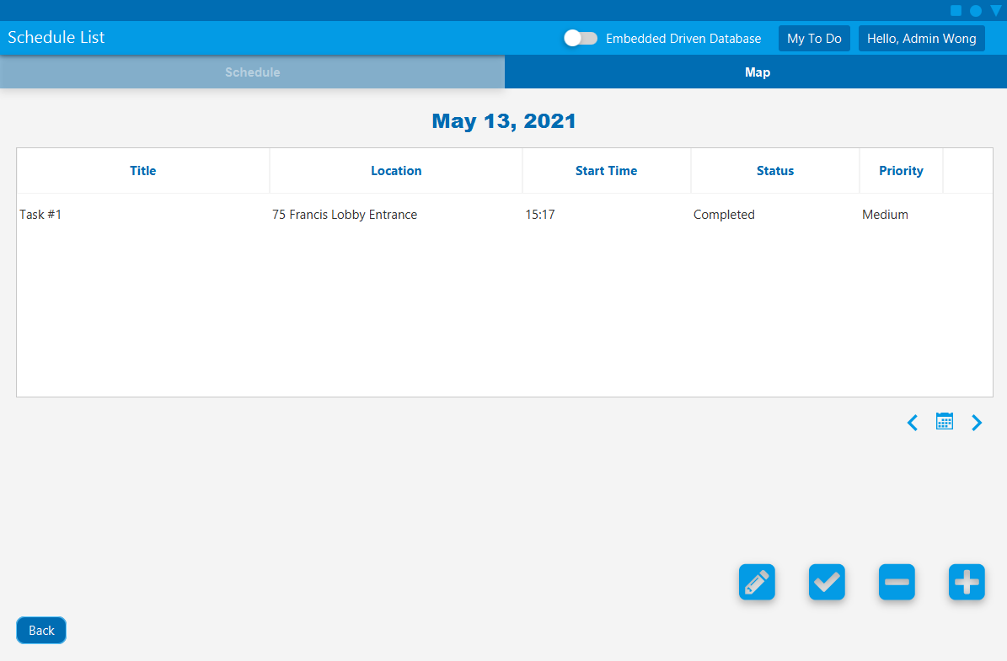

## Delete a To-Do

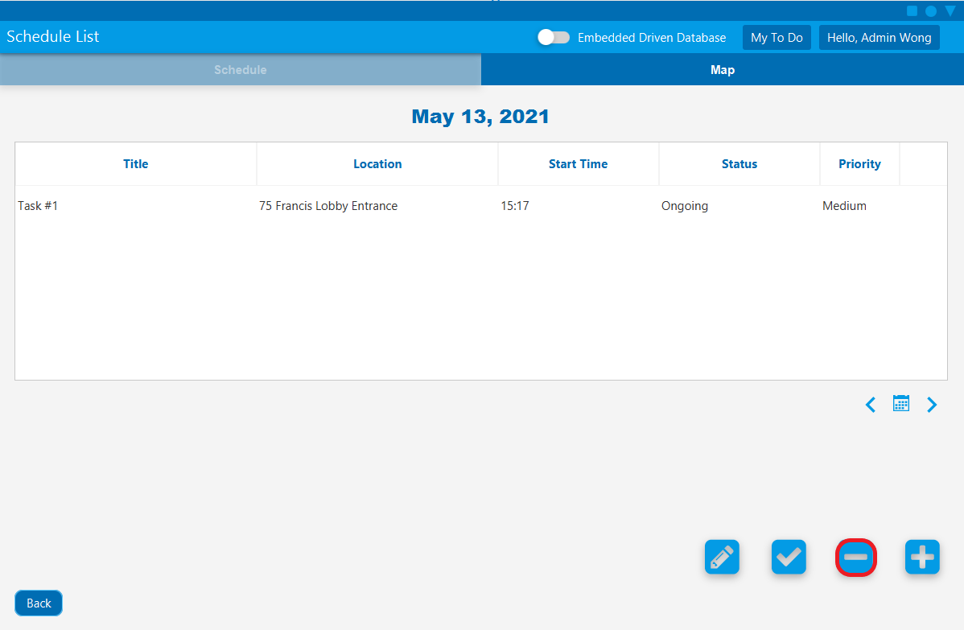

Select a to-do item and click the **delete to-do** button to delete a to-do.

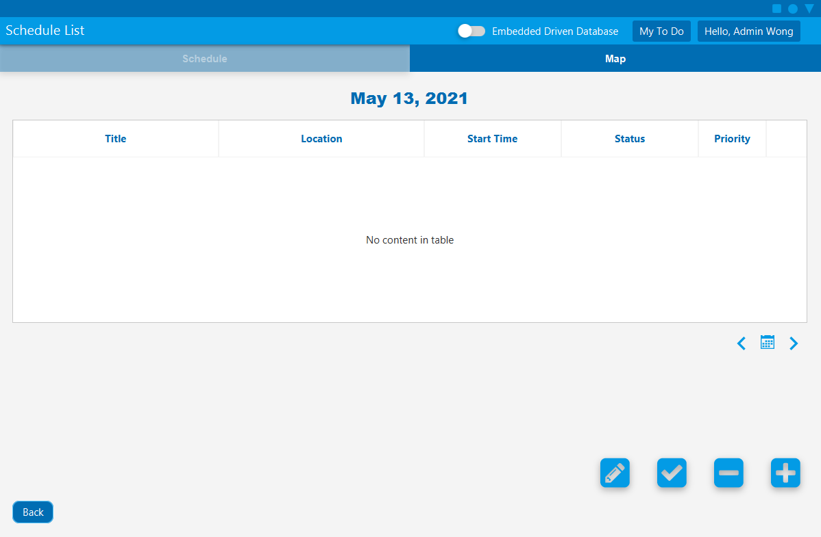

## Show Today’s Scheduled Path

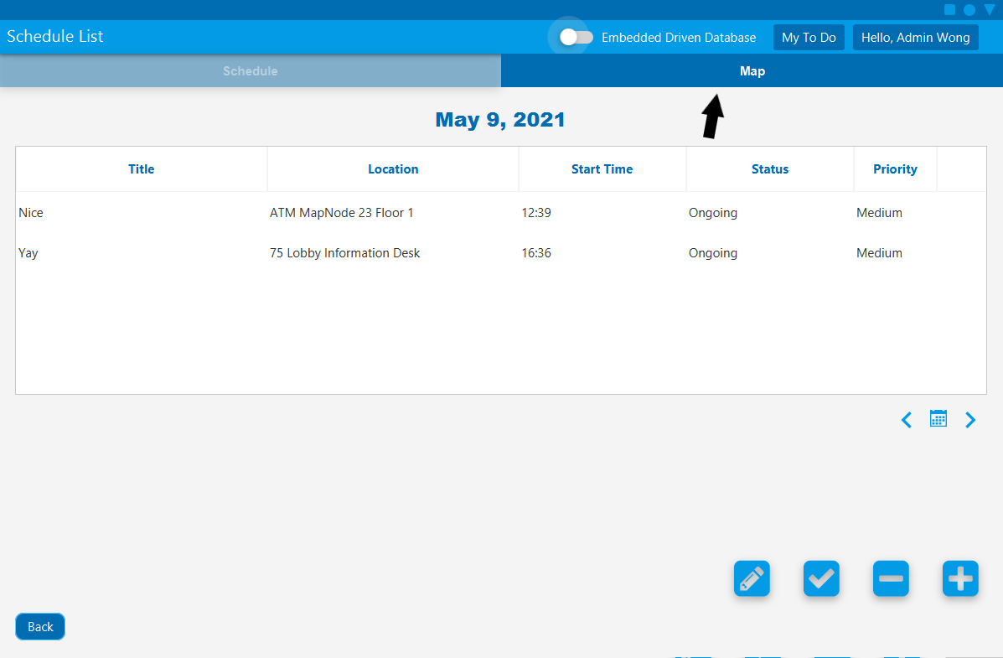

When in the To-Do page, click the **Map** tab to enter the Map page

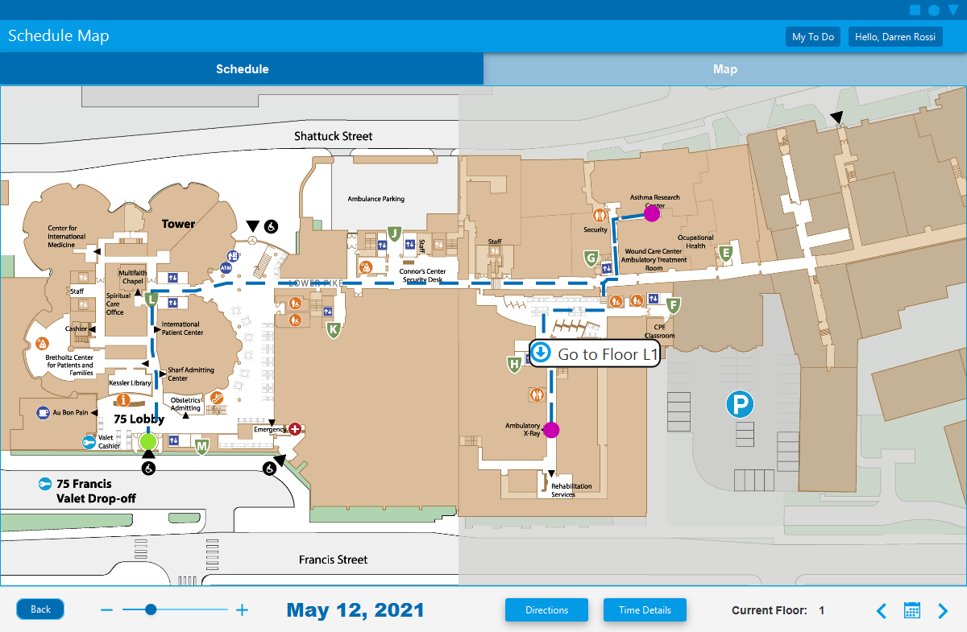

You will see an animated path from 75 Lobby Entrance to each node on your list of scheduled and uncompleted To-Do locations for today, sorted by scheduled time. You won’t see To-Dos item here if they have no associated location, are not scheduled for today, or areundated.

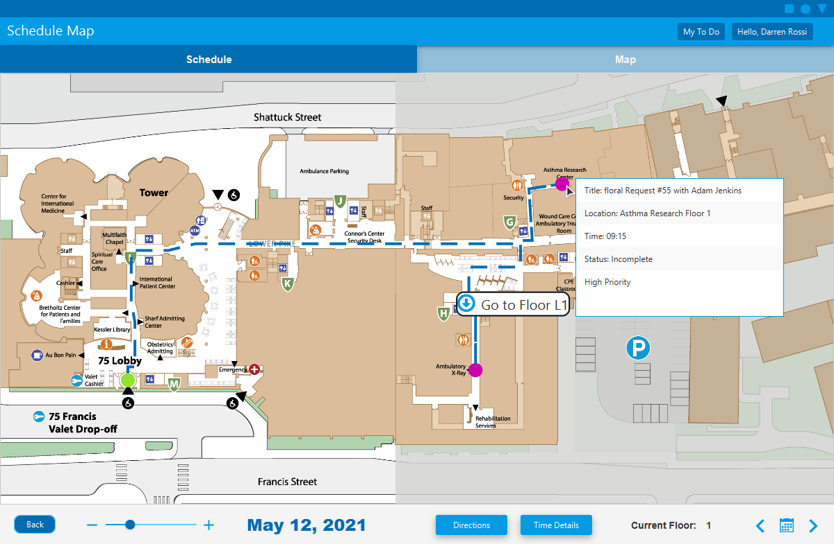

You can hover your mouse cursor over a node to look at the associated To-Do's information. You can click the node to go to the To-Do view and edit page.

## Editing To-Dos that are linked to service requests or appointments:

Edits can be made to one and will update the other.

Changes are automatically synchronized between the two linked items, here is what fields were linked:

* To-Do's Status <==> Request’s Status
* To-Do's Assigned User <==> Request’s Assignee
* To-Do's Assigned User <==> Appointment’s Assigned Doctor
* To-Do’s Scheduled Date <==> Appointment’s Appointment Date
* To-Do’s Start Time <==> Appointment’s Appointment Time

Patients cannot choose a location when they make an appointment, you can add a location by editing the associated To-Do's location field.

## Edit To-Dos that are Linked with Appointments

You can edit to-dos with their attached appointments to assign the appointment to your co-workers.

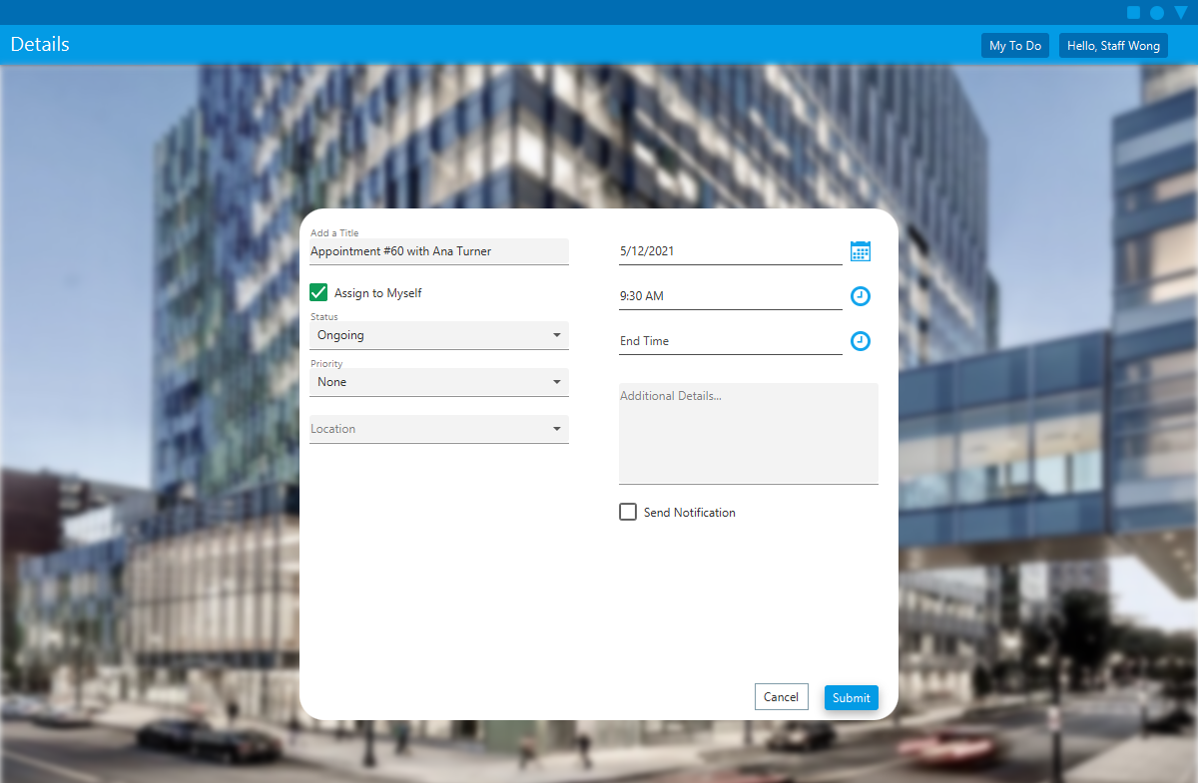

Uncheck the **Assign to Myself** checkbox to see list of co-workers.

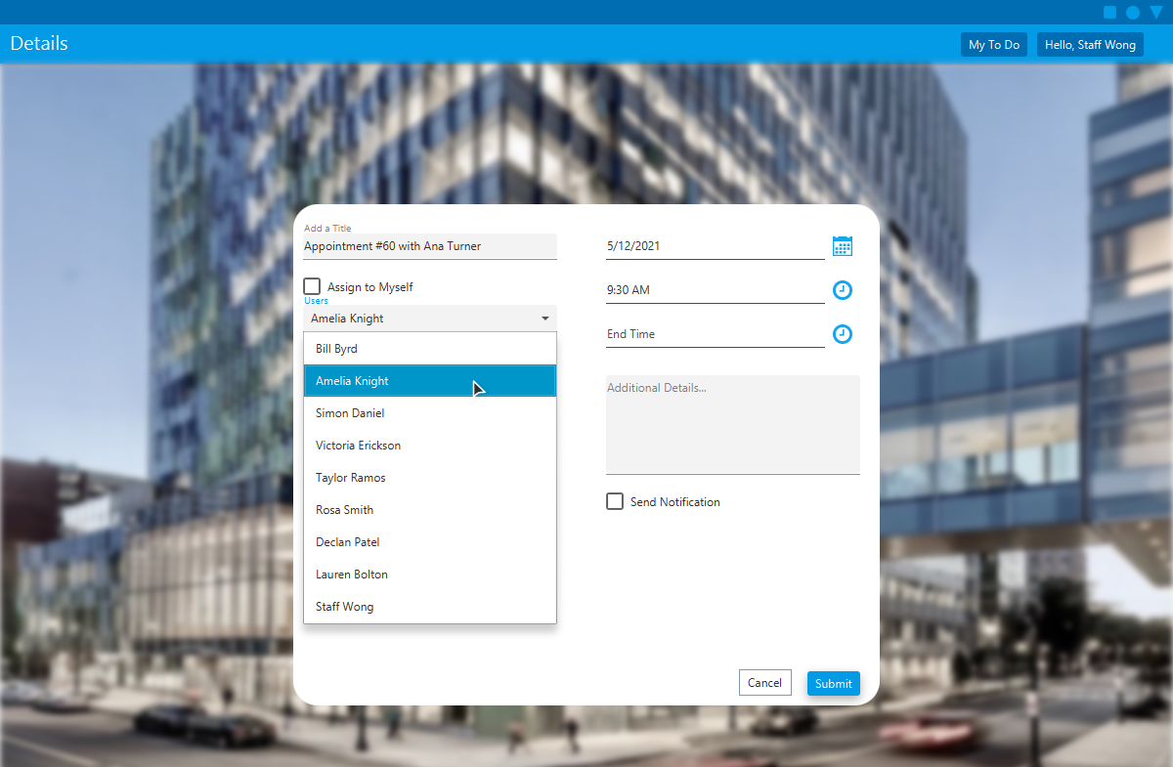

Select the new assigned doctor.

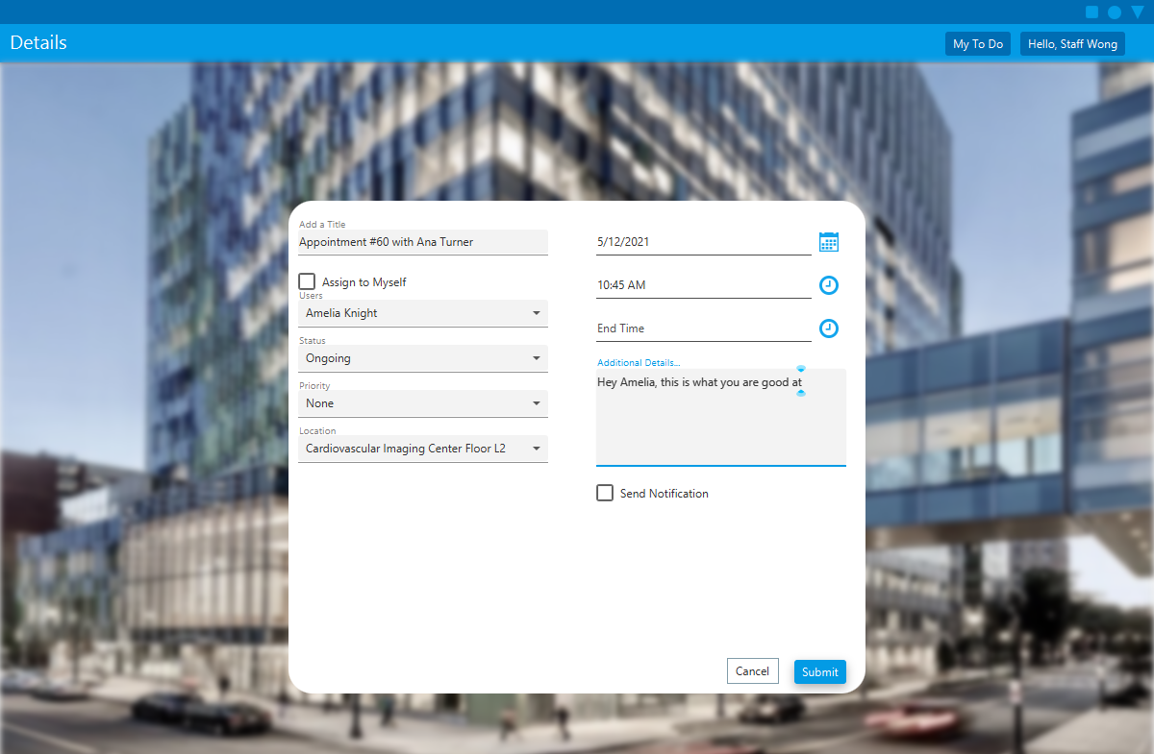

[Optional] Populate more fields like details and location for them.

# Directions to Brigham and Women’s

This application provides Google Maps Directions to the hospital.

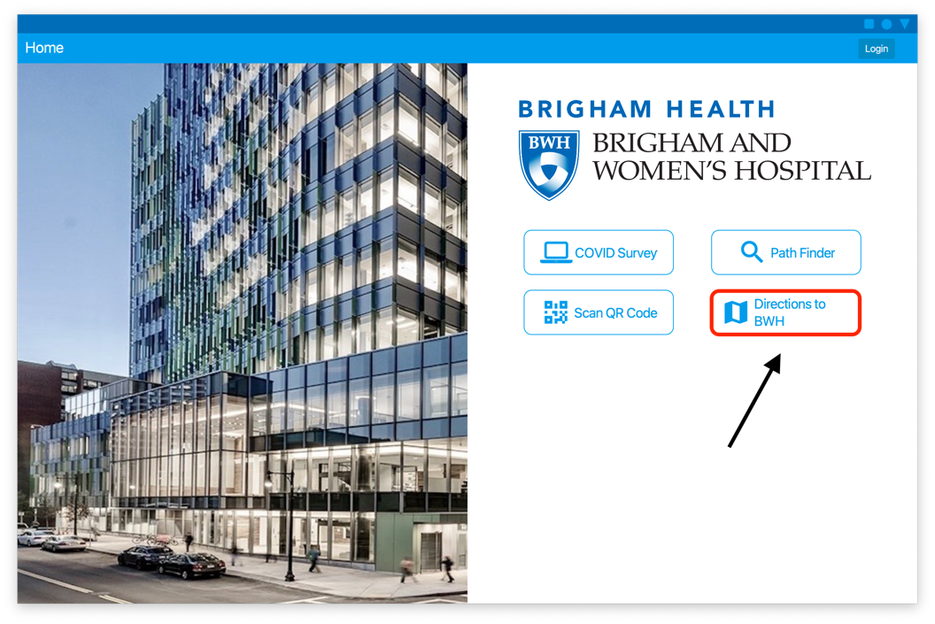

To get directions to and from the Brigham and Women’s Hospital, click on the **Directions to BWH** button on the home page.

## Address Entry

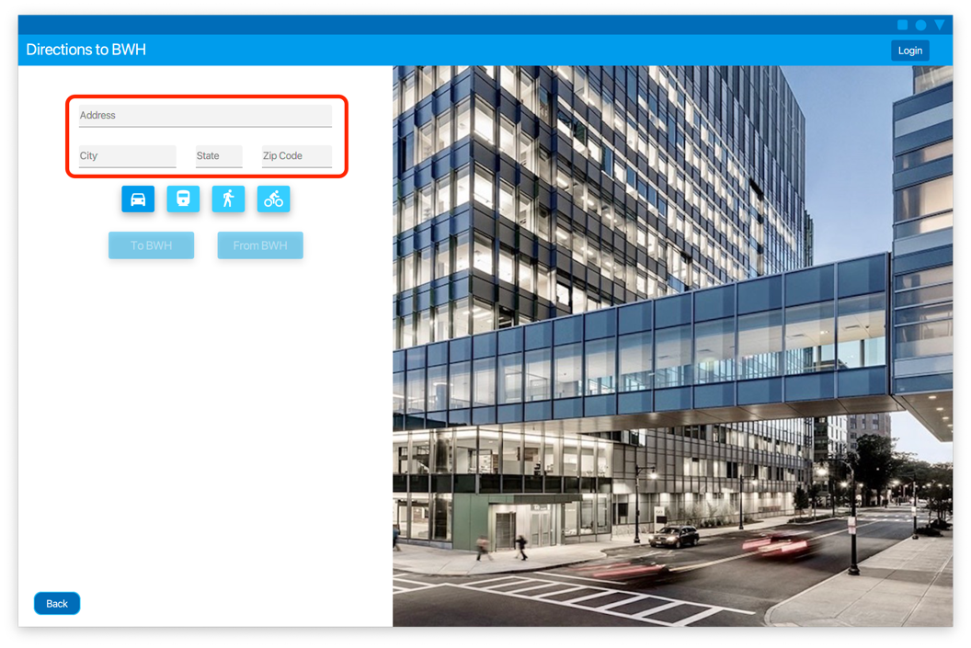

Fill out the address of the location you wish to navigate to or from using the appropriate text fields.

## Transit Mode Change

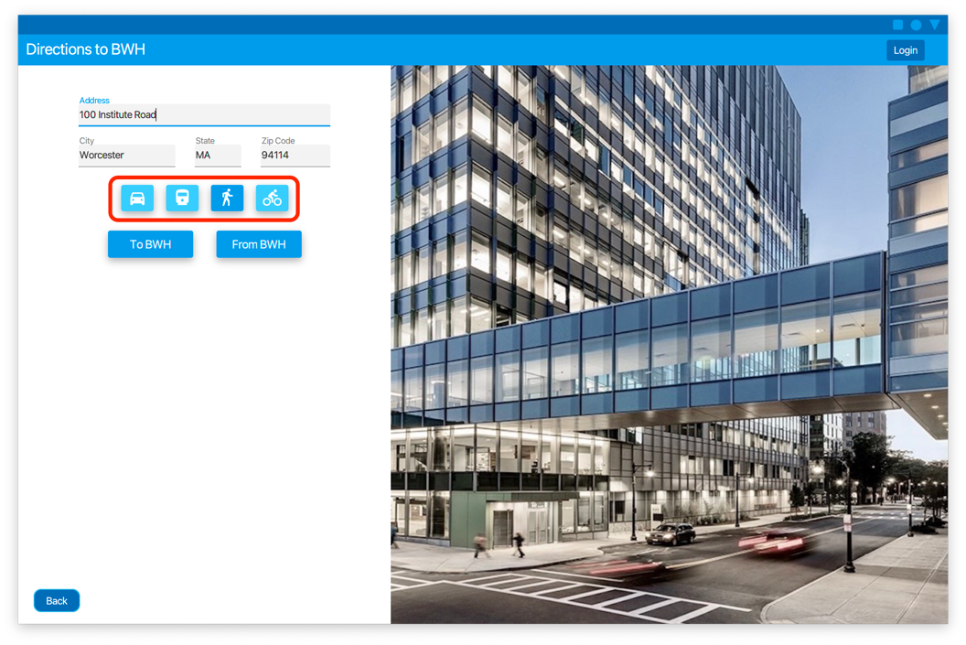

Directions can be given for **Driving**, **Public Transit**, **Walking**, or **Biking**. To change the travel method, simply click the appropraite button for the desired method.

## Directions to Brigham and Women’s

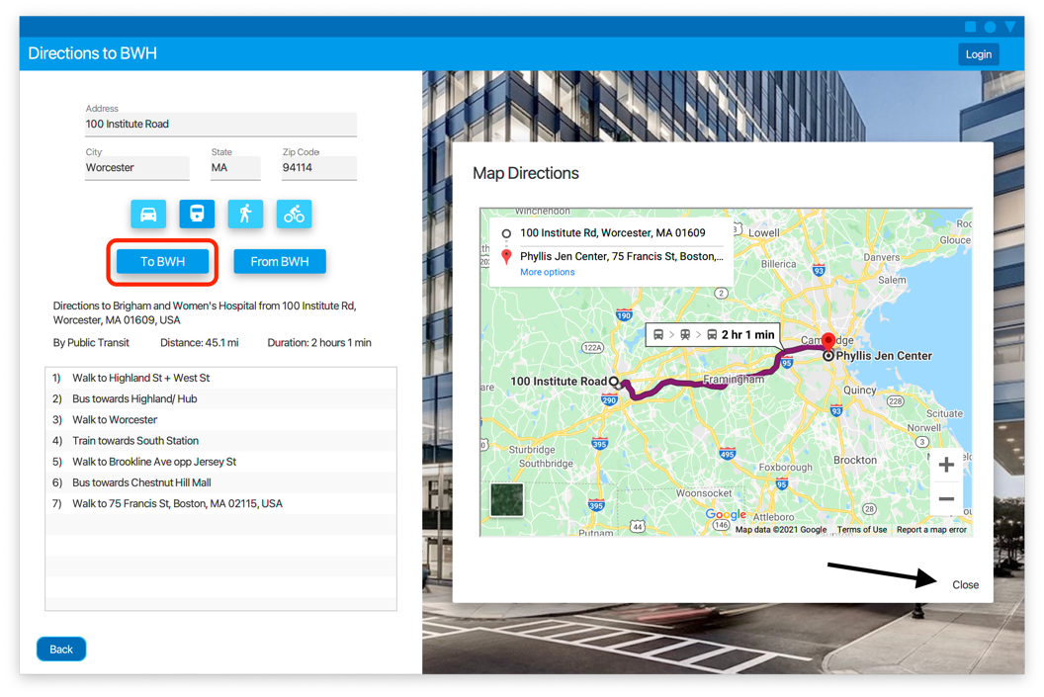

To get directions from the entered location to the hospital click the **To BWH** button. A list with the textual directions written out will appear underneath the buttons along with estimate distance and duration. A pop-up with an annotated map will open over the image of the hospital on the right. To close the map pop-up, click the **Close** button on the bottom right of the pop-up. If **Driving** directions are selected the application will give directions to the parking lot closest to the origin location rather than the main building entrance, to make parking easier. If another travel method is selected the directions will direct to the main 75 Francis entrance.

## Directions from Brigham and Women’s

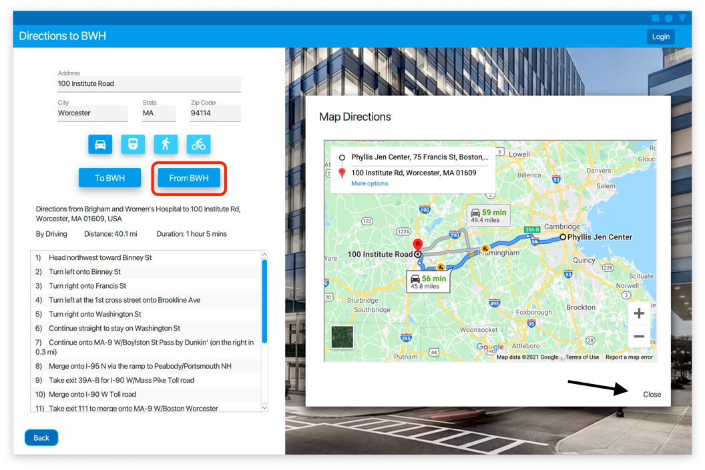

To get directions from the hospital to the inputted location click the **From BWH** button. As with directions to the hospital, a list with the textual directions written out will appear underneath the buttons along with estimate distance and duration. A pop-up with an annotated map will open over the image of the hospital on the right. To close the map pop-up, click the **Close** button on the bottom right of the pop-up.

## Returning to the Home Page

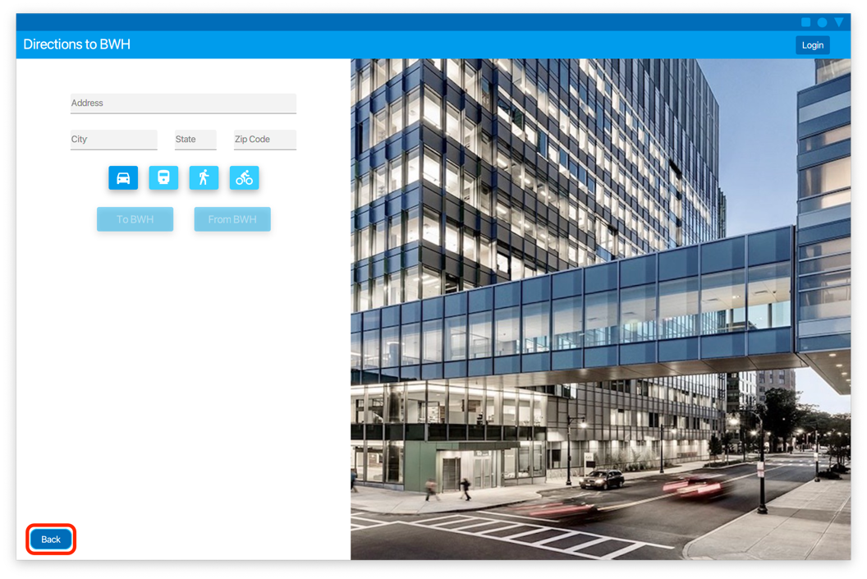

To leave the Directions to BWH page click the **Back** button in the bottom left of the page to return to the home page.

# Appointment Scheduling

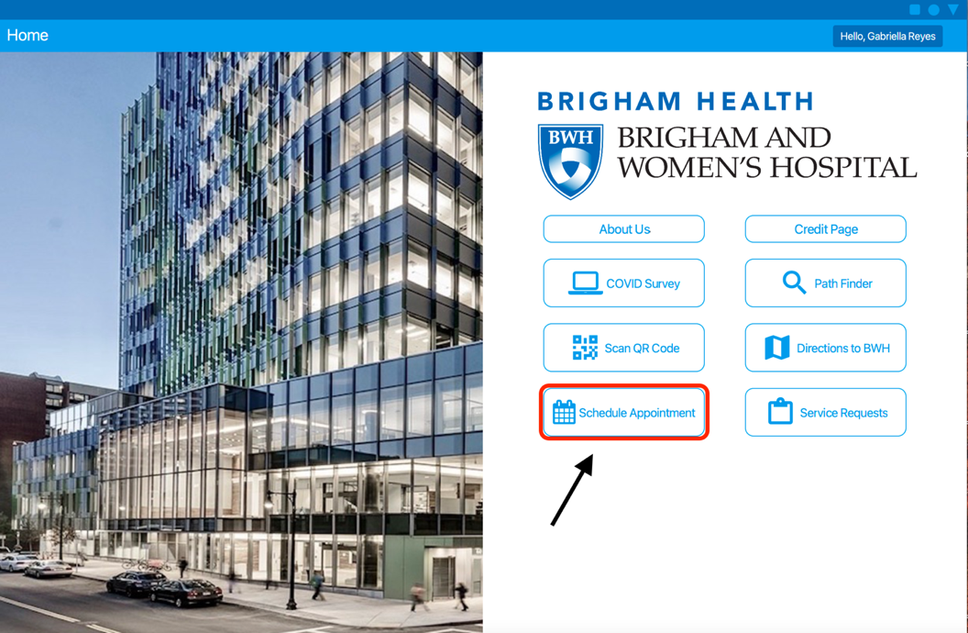

To create an appointment after you are logged into your account, select the “Schedule Appointment” menu option located on the home page.

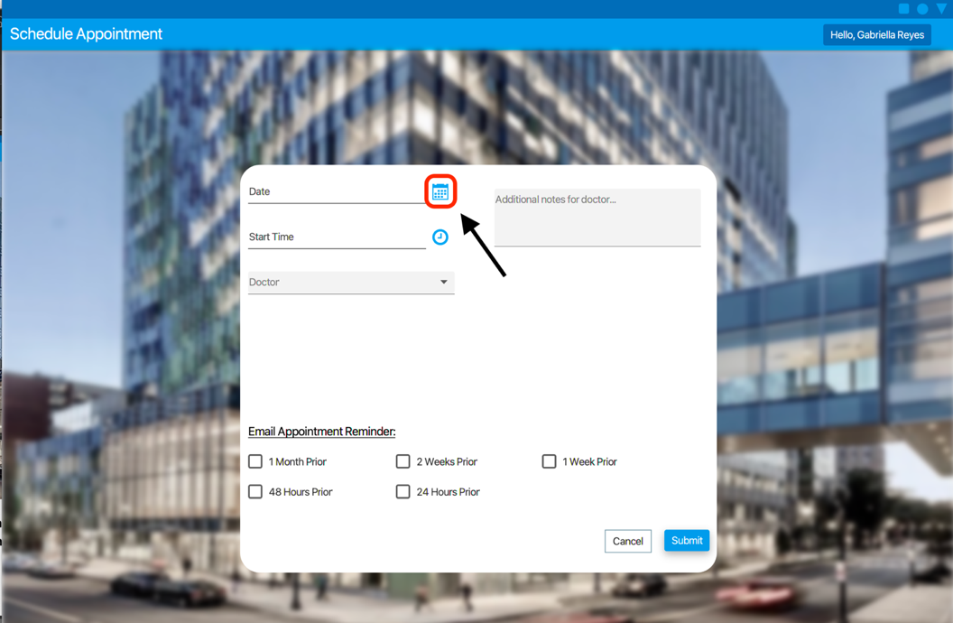

When the schedule appointment page appears, begin filling out the form by selecting a date. To start choosing a date, select the calendar icon next to the date field.

select a date click the calendar icon next to the date field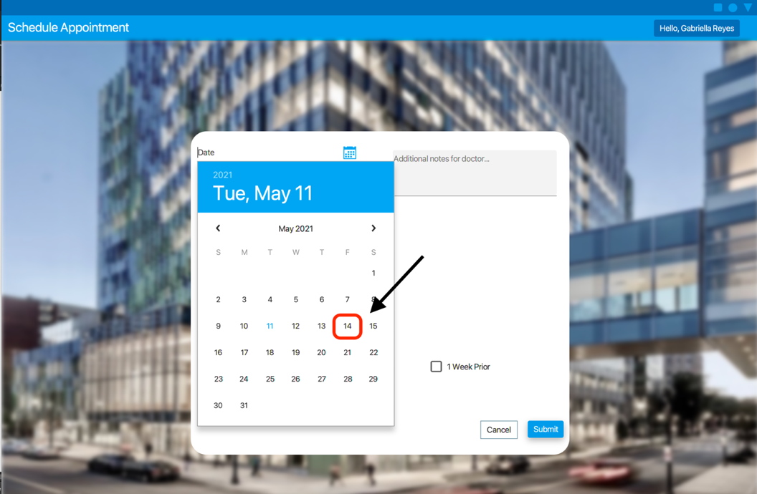

To finish choosing a date, select a day from the displayed calendar. To flip through the months, select the left and right arrows.

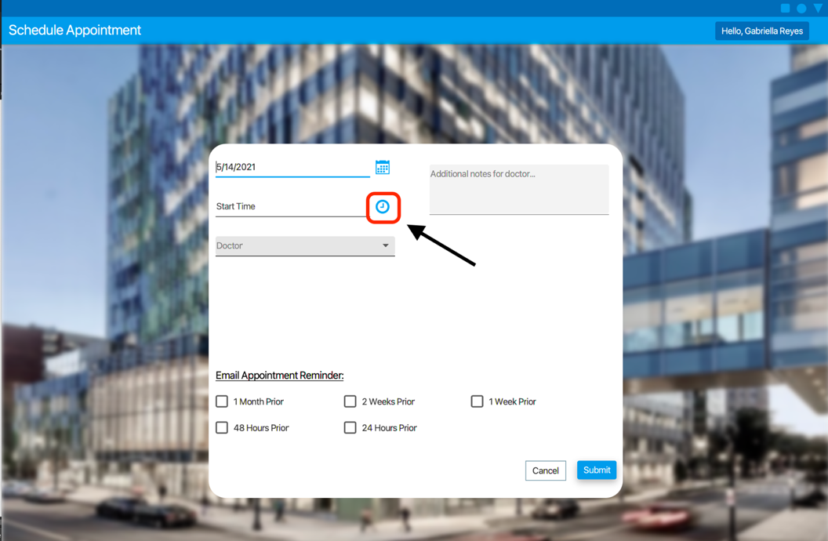

Next begin my selecting an appointment time you wish to schedule your appointment by selecting the time icon next to the Start Time field.

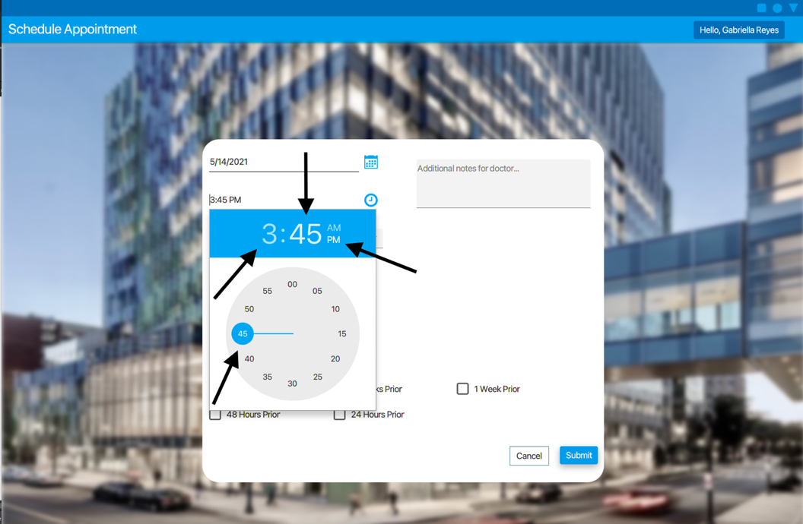

To select a start time, begin by select the digit in the hours place holder. Then drag the blue clock needle by the nob to the select hour you choose. Then select the digits in the minutes place holder to edit the time to be more specific. Again, you can edit this time by dragging the clock hand by the nob. To change the time to PM, select the “PM” next to the displayed time. Likewise, if you wish to book an appointment in the morning, select the “AM” next to the displayed time.

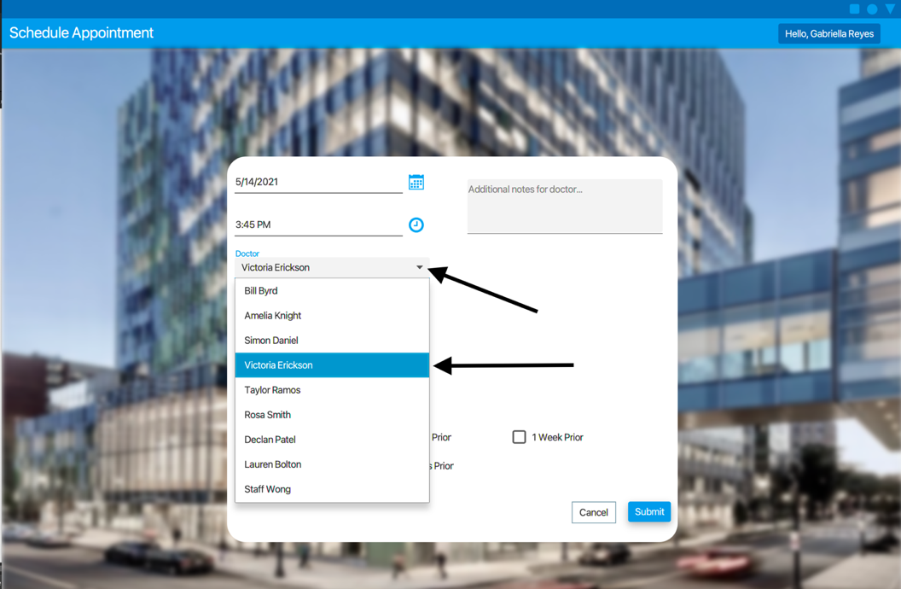

Next to choose a doctor, select the black dropdown arrow on the right side of the field to choose from the available doctors that are working at Brigham & Women’s Hospital. When the list of doctors appears in the drop down click the doctor you want to examine you during your appointment.

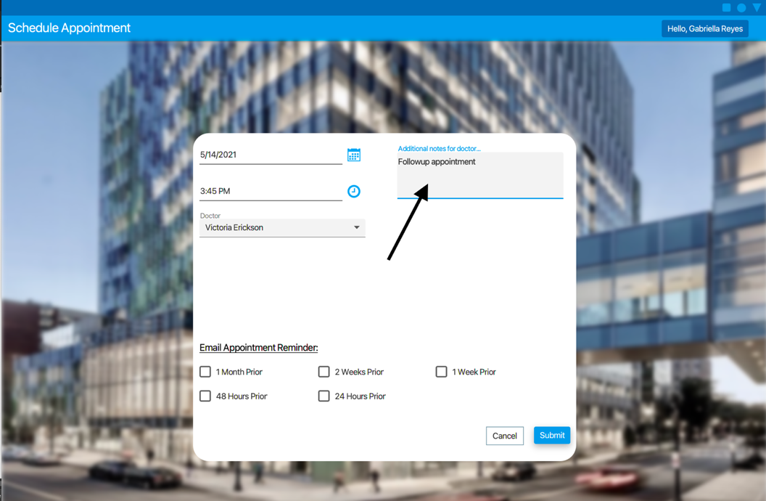

Click in the text field and begin typing any information you would like to provide for your doctor before the appointment.

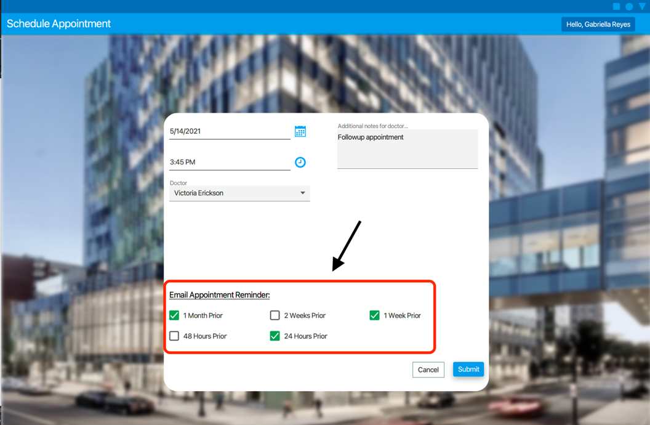

Next, if you would like to receive a reminder email before you scheduled appointment time, select from the available options. You may click as many of the options as you would like, or you could choose none if you would like.

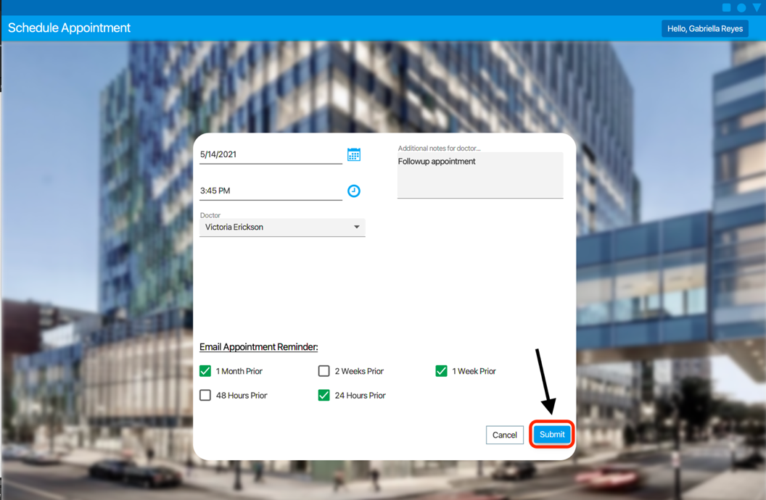

To submit your application, click the submit button in the bottom right-hand corner of the form.

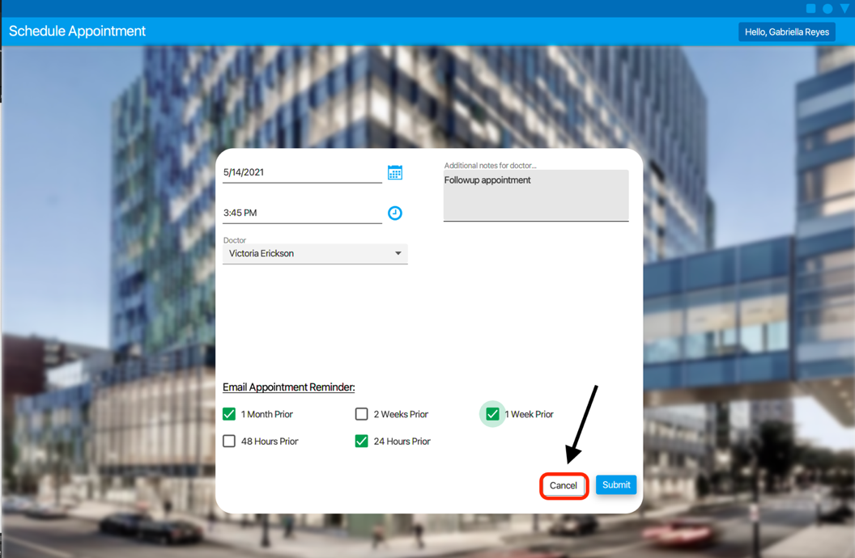

If you would like to cancel your appointment select the cancle button located in the bottom right-hand corner of the form.

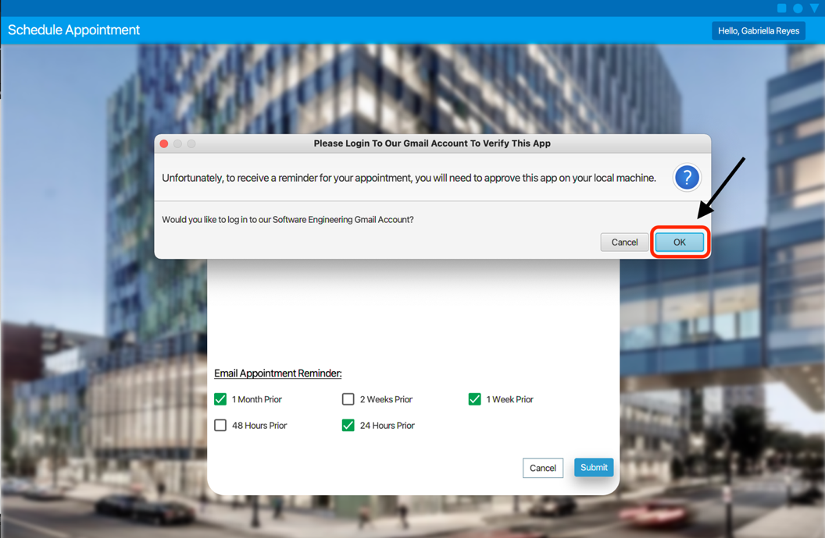

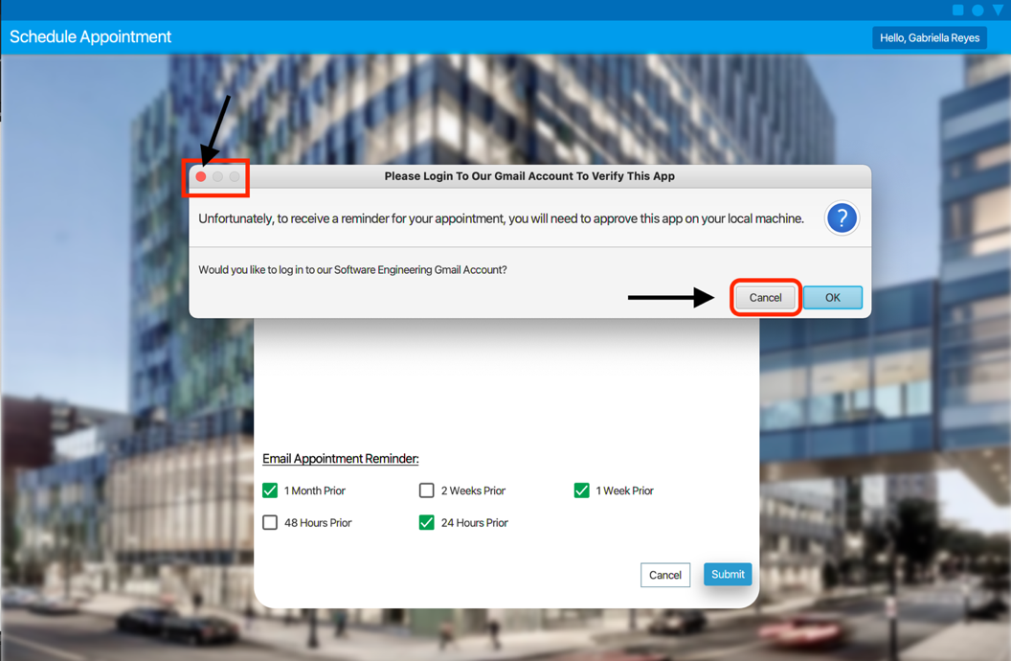

# COVID Survey

## Filling Out a COVID Survey

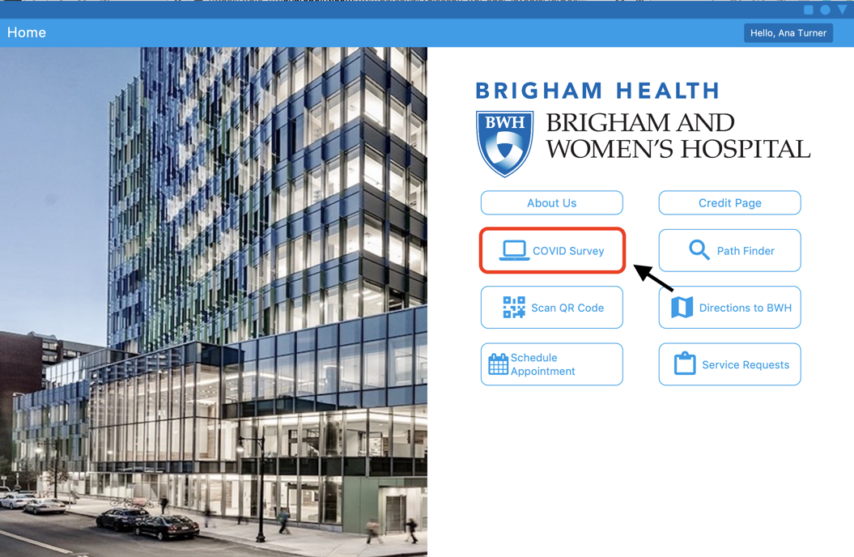

Select the **COVID Survey button** to bring up the COVID Survey Page.

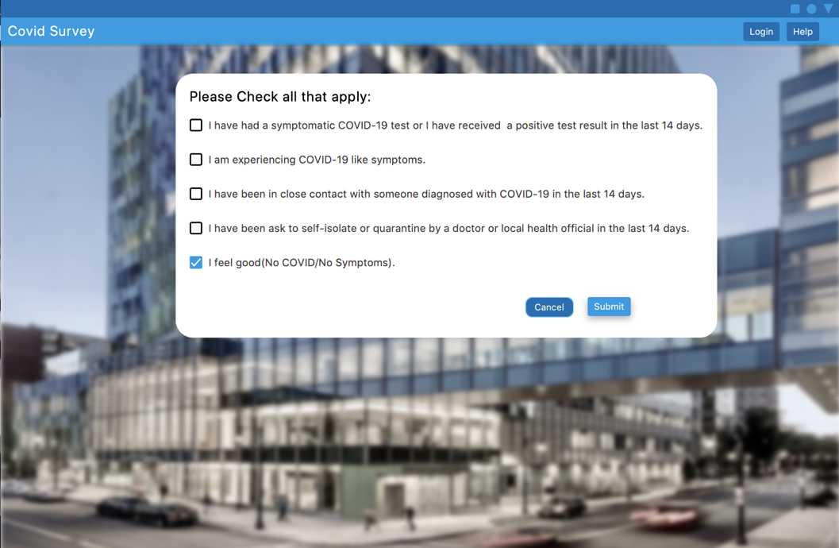

Select all your symptoms and hit the **Submit button**.

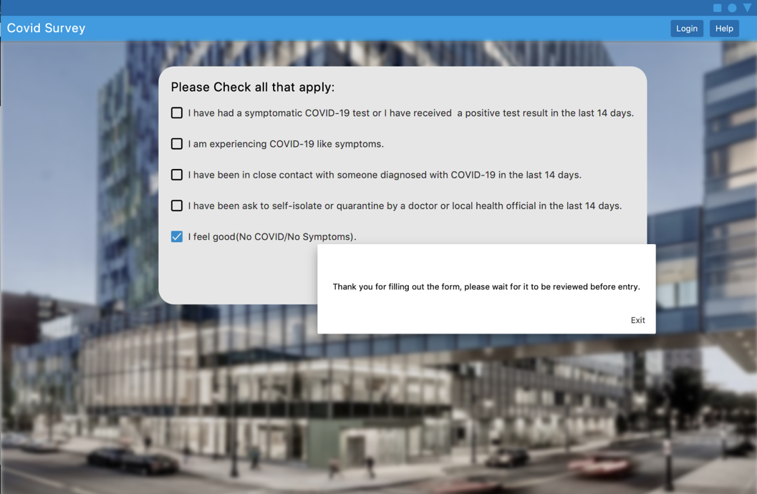

This will bring up a dialog box telling you that your entry request is being reviewed.

## Approving a User for Entry

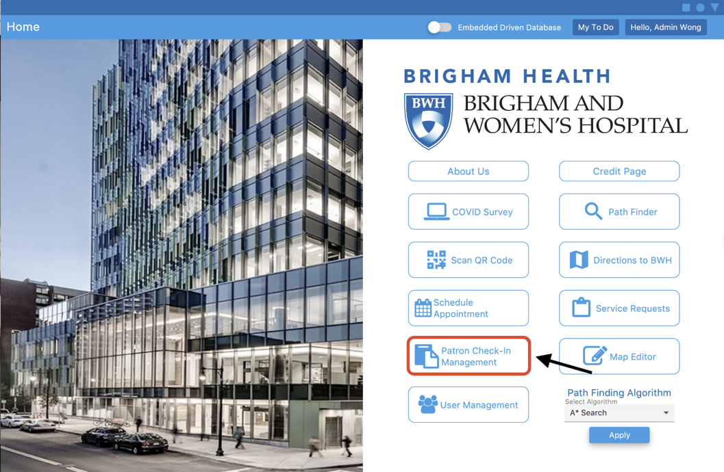

In an admin account, the admin will be able to select the **Patron Check-In Management button**.

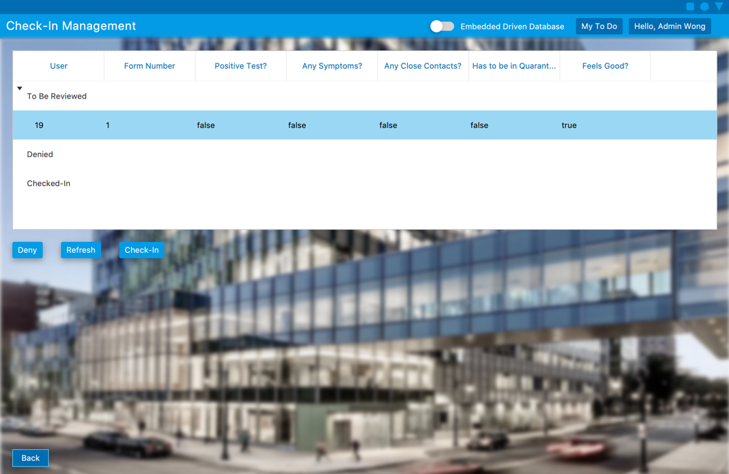

Any filled out COVID surveys will show up in the list and the admin can either select **Deny** to deny the user’s entry request or **Check-In** to check in the user.

# Logger

If you would like to check your logs you should open the install directory of the application and look for the files *BWHApplication.log.0* and *BWHApplication.log.1*. These files will contain basic logger information about

# Crash Report

If the application crashes, you will be prompted to submit a crash report. If you click okay a report will be sent to the developers of the application.

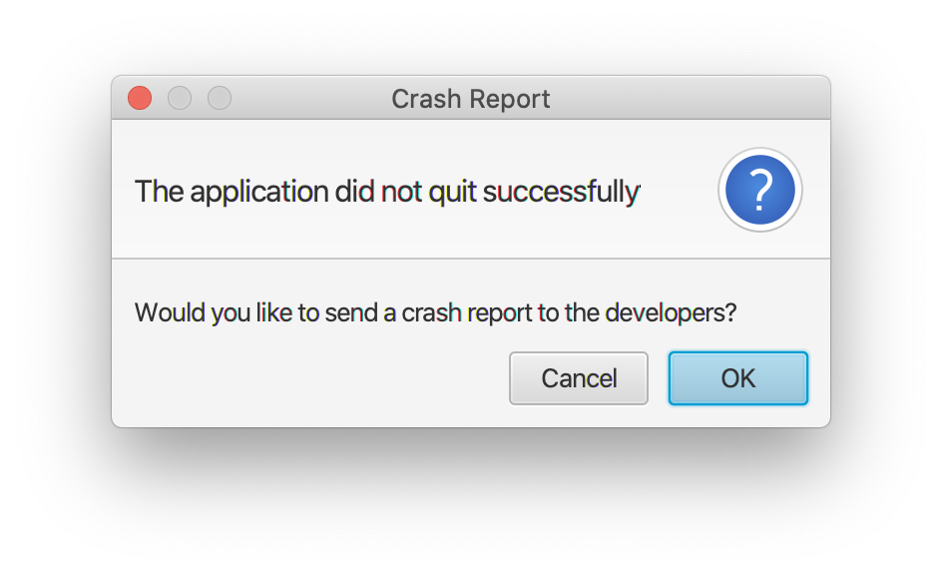

If you would rather view the crash report yourself, you may open the BWC*rash.log* file. It will contain the information leading up to the application crash.